Study on Design and Development of a Web-based Application for Enterprise Product Management System

A Project Report
submitted to the Department of Computer Science and Engineering, Jahangirnagar University in partial fulfillment of the requirements for the degree of Master of Science in Computer Science under PMSCS program.

Submitted by:
Md. Rashedul Haider Rashel
Roll: CSE202203051
Batch: 30th

Supervised by:

Dr. Md. Humayun Kabir
Professor
Department of Computer Science and Engineering
Jahangirnagar University, Savar, Dhaka-1342, Bangladesh


Department of Computer Science and Engineering
Jahangirnagar University, Savar, Dhaka-1342

Approval of Acceptance

This project report written by Md. Rashedul Haider Rashel, Roll: CSE202203051 entitled “Study on Design and Development of a Web-based Application for Enterprise Product Management System” is submitted to the PMSCS Program, Department of Computer Science and Engineering, Jahangirnagar University in partial fulfillment of the requirements for the degree of Master of Science in Computer Science. The project is done under the supervision of Professor Dr. Md. Humayun Kabir, Department of Computer Science and Engineering, Jahangirnagar University.
We have examined this report and recommend its acceptance.

……………………………………………..
Professor Dr. Md. Humayun Kabir
Supervisor and 1st Examiner
Department of Computer Science and Engineering
Jahangirnagar University
Savar, Dhaka-1342, Bangladesh

…………………………………………….
Professor Dr. Liton Jude Rozario
Second Examiner
Department of Computer Science and Engineering
Jahangirnagar University
Savar, Dhaka-1342, Bangladesh

Accepted by:

…………………………………
Professor Dr. Md. Humayun Kabir
Coordinator
PMSCS Program 2022-2023
Department of Computer Science and Engineering Jahangirnagar University
Savar, Dhaka-1342, Bangladesh

Declaration

I, hereby, declare that the work presented in this report is the outcome of the investigation performed by me under the supervision of Professor Dr. Md. Humayun Kabir, Department of Computer Science and Engineering, Jahangirnagar University. The work was spread over one final semester course: Research Project, in accordance with the course curriculum of the department for the Professional Master of Science in Computer Science.

-----------------------------------
Md. Rashedul Haider Rashel
Roll Number: CSE202203051
Batch: 30th

Acknowledgment

First, I express my heartiest thanks and gratefulness to almighty for his divine blessing makes me possible to complete the final year project successfully.
I am grateful and wish my profound indebtedness to my supervisor Professor Dr. Md. Humayun Kabir, Department of Computer Science and Engineering, Jahangirnagar University for his endless patience, scholarly guidance, continual encouragement, constant and energetic supervision at all stage have made it possible to complete this project.
I would like to express my heartiest gratitude to Professor Dr. Md. Humayun Kabir, Coordinator, PMSCS Program 2022-2023, Department of Computer Science and Engineering, for his kind help to finish our project and the honorable faculty members and the staffs of my department.

Finally, I must acknowledge with due respect the constant support and patients of my parents.

Abstract

Enterprise Product Management System is an automated system of manual product, supplier, purchase, sell, etc, especially a manual calculating system. This web-based system can handle all the purchase information, purchase return information, and customer, client, and supplier information. Here using JavaScript for calculating the number of product units with unit price, calculating sell commission, market commission, special commission, and discount of sub-total. This calculation is automatically from Grand total. Then send the invoice to email and SMS with the unique URL of the invoice PDF. Which can be downloaded from anywhere, anytime, on any devices. Also generating thermal POS print as a print report. With this system all customer management is easy to maintain, who has due amount is to be notified by SMS/Email also print the total number of due customers. Product-related stock is clearly shows up, how many products are now available in stock to sell. For this web-based project, the system will be developed by using Laravle MVC (Model, View, and Controller) pattern. To design a front-end for the end users to insert, update, and delete. MySQL database will be designed by using normalization, and relation with each other.

Table of Contents

Page No.
Approval of Acceptance | ii
Declaration | iii
Acknowledgement | iv
Abstract | v

Chapter 1 Introduction
 | 1.1 | Motivation |  | 1
 | 1.2 | Objectives |  | 1
 | 1.3 | Scope Of The Project |  | 2
 | 1.4 | Problem Definition |  | 2
 | 1.5 | Research Methodology |  | 3
 | 1.6 | Outline |  | 3
Chapter 2 Web-based Application Development
 | 2.1 | Web-based System |  | 5
 | 2.2 | Web Servers Configurations |  | 6
 | 2.3 | Working Process Flowchart |  | 7
 | 2.4 | Home Page Design |  | 7
 | 2.5 | Dashboard Design |  | 7
 | 2.6 | User Interface Design |  | 8
 | 2.7 | Tools and Technologies |  | 9
Chapter 3 Object-Oriented Analysis and Design of Enterprise Product Management System
 | 3.1 | Object-Oriented Analysis and Design |  | 10
 | 3.2 | Requirements Gathering |  | 10
 | 3.3 | Requirements Analysis |  | 12
 | 3.4 | Use Case Diagram |  | 14
 | 3.5 | Data Flow Diagram |  | 15
 | 3.6 | GUI Design |  | 17
 | 3.7 | ERD and Database Design |  | 18
Chapter 4 Implementation and Results
 | 4.1 | Code |  | 19
 | 4.2 | Controller Class Code |  | 20
 | 4.3 | Model class files |  | 26
 | 4.4 | Database Tables Structure |  | 26
 | 4.5 | Graphical User Interface (GUI) |  | 33
 |  | 4.5.1 | User Registration Interface | 33
 |  | 4.5.2 | Login Panel | 34
 |  | 4.5.3 | Dashboard | 34
 |  | 4.5.4 | User Information update | 35
 |  | 4.5.5 | User Password Update | 35
 |  | 4.5.6 | Forget Password | 35
 |  | 4.5.7 | Forget Password Verification link | 36
 | 4.6 | Menu Bar |  | 37
 |  | 4.6.1 | Supplier Interface | 38
 |  | 4.6.2 | Category Interface | 38
 |  | 4.6.3 | Units Interface | 39
 |  | 4.6.4 | Product Interface | 40
 |  | 4.6.5 | Customer Interface | 41
 |  | 4.6.6 | Delivery Zone Interface | 42
 |  | 4.6.7 | Sales Representative (SR) Interface | 42
 |  | 4.6.8 | Purchase Receipt Interface | 43
 |  | 4.6.9 | Purchase Payment | 45
 | 4.7 | Sales Invoice |  | 46
 |  | 4.7.1 | Sales Invoice Dashboard | 47
 |  | 4.7.2 | Update Sales Invoice Receipt | 48
 |  | 4.7.3 | Print Sales Invoice Receipt | 48
 | 4.8 | Testing Reports |  | 49
 |  | 4.8.1 | Purchase Report | 49
 |  | 4.8.2 | Purchase Payment Report | 50
 |  | 4.8.3 | Sales Invoice Report | 51
 |  | 4.8.4 | Customer wise Invoice Report | 52
 |  | 4.8.5 | Customer Due Report | 53
 |  | 4.8.6 | Product List Report | 53
 |  | 4.8.7 | Product Stock Report | 55
Chapter 5 Conclusion and Future Work
 | 5.1 | Conclusion |  | 56
 | 5.2 | Contribution |  | 56
 | 5.3 | Future Work |  | 57
References |  |  |  | 58

List of Figures
Figure No. |  | Page No.
Figure 2.1 | Web-based system scenario | 5
Figure 2.2 | Working Process Flowchart | 7
Figure 3.1 | Use Case Diagram | 13
Figure 3.3 | Level 0 DFD | 14
Figure 3.4 | Level 1 DFD | 15
Figure 3.5 | Level 2 DFD | 16
Figure 3.6 | Laravel Framework Architecture | 17
Figure 3.7 | PHP Laravel Application Life cycle | 17
Figure 3.8 | Entity Relationship Diagram | 18
Figure 4.1 | XAMPP Control Panel | 19
Figure 4.2 | Command To Start Php Server | 19
Figure 4.3 | Lists of Controller Class | 20
Figure 4.4 | Lists of EPMS Model | 26
Figure 4.5 | PHP MySQL Database Tables Lists | 26
Figure 4.6 | Users Tables Structure | 27
Figure 4.7 | Supplier Tables Structure | 27
Figure 4.8 | Category Tables Structure | 28
Figure 4.9 | Units Tables Structure | 28
Figure 4.10 | Customer Tables Structure | 28
Figure 4.11 | Products Tables Structure | 29
Figure 4.12 | Purchase Tables Structure | 29
Figure 4.13 | Purchase Details Tables Structure | 30
Figure 4.14 | Purchase Payment Tables Structure | 30
Figure 4.15 | Sales Invoice Tables Structure | 31
Figure 4.16 | Sales Invoice Details Tables Structure | 32
Figure 4.17 | Sales Payment Details Tables Structure | 32
Figure 4.18 | User Registration Form | 33
Figure 4.19 | Login form | 34
Figure 4.20 | User Dashboard | 34
Figure 4.21 | User Information Update | 35
Figure 4.22 | User Password Update | 35
Figure 4.23 | User Forget Password Form | 36
Figure 4.24 | Password Reset Verification Link On Email | 36
Figure 4.25 | Set New Password Form | 37
Figure 4.26 | Menu Bar | 37
Figure 4.27 | Supplier Add Interface | 38
Figure 4.28 | All Supplier Data Interface | 38
Figure 4.29 | Category Form | 39
Figure 4.30 | Units Form | 39
Figure 4.31 | Add Products Form | 40
Figure 4.32 | All Products Details | 40
Figure 4.33 | Customer Details Form | 41
Figure 4.34 | Delivery Zone Form | 41
Figure 4.35 | Sales Representative (SR) Form | 42
Figure 4.36 | Add Purchase Form | 43
Figure 4.37 | Purchase Dashboard Form | 43
Figure 4.38: | Purchase Receipt Update Form | 44
Figure 4.39 | Updated Purchases List | 44
Figure 4.40 | Make Purchase Payment | 45
Figure 4.41 | Purchase Payment list | 45
Figure 4.42 | Sales Invoice Form | 46
Figure 4.43 | Sales Invoice Dashboard | 47
Figure 4.44 | Update Sales Invoice Form | 47
Figure 4.45 | Sales Invoice Receipt Print | 48
Figure 4.46 | Purchase Report | 48
Figure 4.47 | Purchase Payment Report | 50
Figure 4.48 | Sales Invoice Report | 51
Figure 4.49 | Customer Invoice Report | 51
Figure 4.50 | Customer Due Report | 52
Figure 4.51 | Product Lists Report | 53
Figure 4.52 | Product Stock Report | 54

Chapter 1

Introduction

  - Motivation
I have visited many small or medium companies that are dealing with their goods or products and managing their products and reporting manually like writing tally notebooks or writing somewhere else [2]. And for this manual system, they have fetched lots of problems and most of the time it's taking more time and chance to wrong calculation to manage their products [1]. So that a business cannot grow up, cannot increase or not get any benefit. So, a business must need to be an automated system to carry out its business progress. There are some businesses that are using Software or automated systems but most of the small or medium businesses are out of this opportunity [2]. So, only for this reason, I have thought about this project for the low-budget organization.

  - Objective of The Project
The main objective of this Implementation of Enterprise Product Management System project is to design and implement for the easy to maintain, data accuracy, large data control, high availability and ensure security [2][3].
Following are the features and objectives of this system.
- Supplier Management
- Stakeholder Management / Client Management
- Product Management
- Unit Management
- Categories Management
- Purchase Management
- Purchase Return
- Invoice Management
- Product Return
- Product wise Bar-code level printing with price, product code, expire date, etc [2]
- All kind of reporting like product wise stock, customer wise credit/due, purchase, return, etc
- Generating Automated report PDF URL link which is through to notify via Email/SMS and it can be downloaded from anywhere, anytime on any devices [1, 2].
- Support ticket [4]

  - Scope of The Project
Monitoring the products is the process of product management. This covers all aspects of product management up until the point of sale [1].
- Manage product: Product management aids in the organization of the company's inventory. It gives the purchasing department accurate information about the products, including what kind of raw material is used, what sizes are needed, and other details [3].
- Less Storage: Product management helps the company store fewer products by giving management accurate information, which allows them to make purchases. [7].
- Improve Productivity: Product management contributes to increased labor and machine productivity. Workers are aware of inventory and the amount needed to produce [1, 4].
- Increase Profits: Product management contributes to the company's increased profitability. Proper information about stocks is helpful in preventing needless stock-related expenses [9].
- Minimizing cost: The way that stores are organized minimizes the cost of storage and material handling for the stores by minimizing the time it takes to bring inventory into and out of the storehouse. [1].

Calculating stock: The difference between the amount stocked to meet demand during a specific time period and the mean expected demand for that period is known as safety stock [5, 22].

  - Problem Definition
The first step is to identify the problem or opportunity that you want to address with product management. For example, you may want to reduce product holding costs, increase product turnover, or improve service levels. You should also consider the objectives and constraints of your project, such as budget, time, quality, and customer expectations. By defining the problem clearly, you can narrow down the scope and focus of your project [11].
Defined the problem statement as:
- To make web-based applications of Product Management for small or medium business [5].
- To make the system easily managed and can be secured.
- To cover all the areas of the application like purchase, sales, stock and payment management [6].
- Every Calculation is done correctly.
- Notify the customer via Email/SMS [4].
- Preserve printed thermal invoices at low cost.
- Report generating in PDF, and Excel format and can save it for more use.
- Customer Due/Credit reports are generated automatically and a customer is notified by Email/SMS [7].
- Using bar-code can reduce the time to take it automatically scanned to invoice product list correctly [2, 3].
- Better product Accuracy.
- Reduced Risk of Overselling.
- Avoiding Stock-outs and Excess Stock.
- Better Terms with Vendors and Suppliers.
- More Productivity.
- Increased Profits.
- More Organized Warehouse or Product Store.
- Better Customer Experience.
- Support Uninterrupted Production.
- Data-Driven Decision Making.
- Automate Manual Tasks.

  - Research Methodology
To implement the project, some open source tools have been used such as,
- Programming Languages: PHP 8.1
- Framework: Laravel-10 MVC
- Scripting Language: HTML5, CSS3, Bootstrap, JavaScript, jQuery
- Database: mySQL/MariaDB
- Server: Apache/Tomcat
- API: Email/SMS integration
- Tools: XAMPP, FileZilla, PDF Generator, JavaScript Library.
- IDE: Visual Studio Code, Notepad++, PhpStrom
- Hardware: Bar-Code Scanner, POS Thermal Printer, Bar-code level printer.

  - Outline
Here is an outline of the key components and functionalities typically found in an product management system:
Chapter 1 describes the objective of The Project. The project objectives why we should build the new system and what was the problem of the existing system. Describing the scope of the project how the project could be used in the practical field. Problem definition the describes how we have faced the problem and how to overcome this type of current problem. Research Methodology the what types of tools and technology do I have to use to design and develop this project?

Chapter 2 describe web server configuration on how to configure and build the web server with necessary other tools. User interface design on how many and what type of user interactions menu and user access interface will be designed? This type of description is discussed in this chapter. Tools and technologies on what types of tools and technology do I have to use to configure full system design?

Chapter 3 describes requirements gathering and analysis on needful requirements gathering and discussing with a practical person have been discussed in this chapter. Diagram design on UML diagram, Class diagram, DFD diagram, ERD, and Database design description are shown here graphically and described elaborately. GUI design on Graphical User Interface for user interactions, and user access.

Chapter 4 describes the code on describing this chapter about controller class code, model class code, and view class code. Using some screenshots for better view and understanding. Database tables structure on All MySQL database tables structures are described with their relationships. Graphical User Interface (GUI) on Login page, Dashboard, Menu Bar, insert form, update form, etc. Testing reports on PDF report generated for each of the sections like, customer details, Date-wise sales information, customer due or paid report, purchase payment, etc.

Chapter 5 describes the conclusion, contributions, and future works are written in this chapter. Especially how this software will be improved with other facilities.

Chapter 2
Web-Based Application Development

2.1 Web-Based System

Quantity and percentage of stocked commodities are specified and managed through web-based enterprise product management [1]. It may be needed in multiple facilities spread across different geographic locations, or in different locations within a single facility [6].
With all of your company's product data at your fingertips, web-based enterprise product management software streamlines operations and reduces costs, which can lead to business growth. You can use your stock movement history at any time. Anywhere you are, you can use your tablet, laptop, or phone to access the system. Additionally, web-based enterprise product management reduces the possibility of human error and helps keep inventory from being lost. [5, 7].

Web-based system scenario
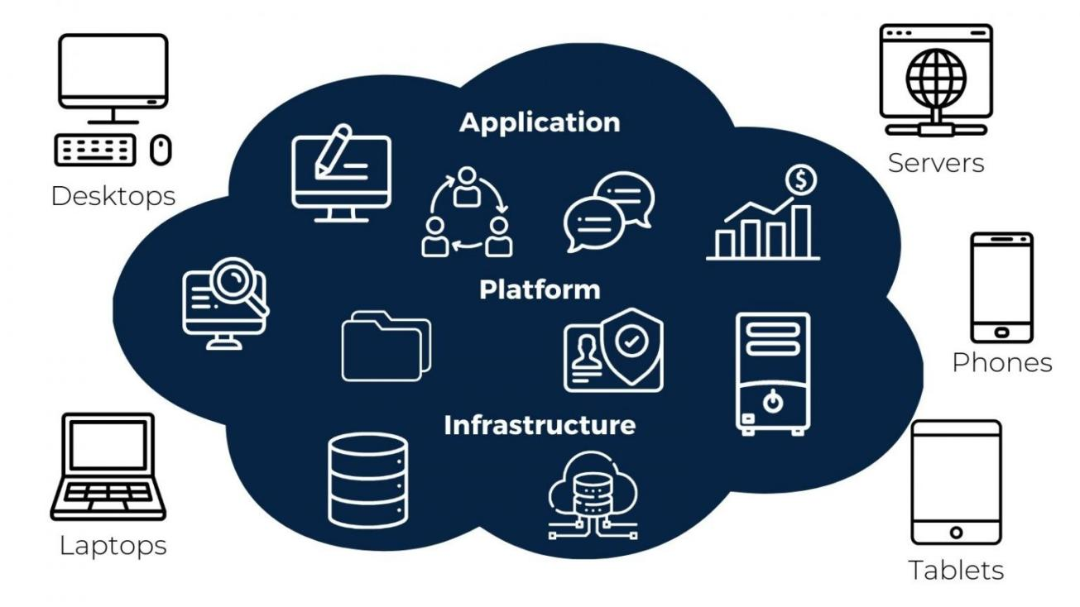
Figure 2.1: Web-Based System Scenario [9].

2.2 Web Server Configuration
XAMPP: XAMPP is an Apache distribution that is easy to install and completely free. It comes with MariaDB, PHP, and Perl. The XAMPP open source package is designed to be extremely simple to use and install [17].
Apache: The most popular server in the world for delivering web content is Apache, an open-source web server. The Apache Software Foundation makes the server program available as free software [20, 21].
MySQL: One of the most widely used relational database management systems on the planet is included in MySQL for XAMPP. Together with the PHP scripting language and web server Apache, MySQL provides data storage for web services [21].
PHP: It is possible for users to construct dynamic web-pages or applications with the server-side programming language PHP. PHP is platform-neutral and compatible with a wide range of database systems [22].
Laravel: Taylor Otwell developed the free and open-source Laravel PHP web framework, which is based on Symphony and designed for the creation of online applications that adhere to the model-view-controller architectural pattern [13, 14].
Node.js setup: An open-source server environment that runs on multiple operating systems, including Windows, Linux, Unix, and macOS, is called Node.js. Using the V8 JavaScript engine, Node.js is a back-end JavaScript runtime environment that allows JavaScript code to be executed outside of a web browser [17].
Bootstrap Plugin Setup: A free and open-source CSS framework designed for front-end web development that prioritizes mobile responsiveness is called Bootstrap [12]. It includes design templates for typography, forms, buttons, navigation, and other interface elements built with HTML, CSS, and JavaScript [14, 23].
Composer JSON Setup: All you need is a composer.JSON file to begin utilizing Composer in your project. This file lists your project's dependencies and might also include additional metadata. Usually, it belongs in the project's or VCS repository's top directory. Although Composer can be used anywhere, it needs to be able to locate the file at the top of your VCS repository in order to publish a package [13, 20, 21].

2.3 Working Process Flowchart
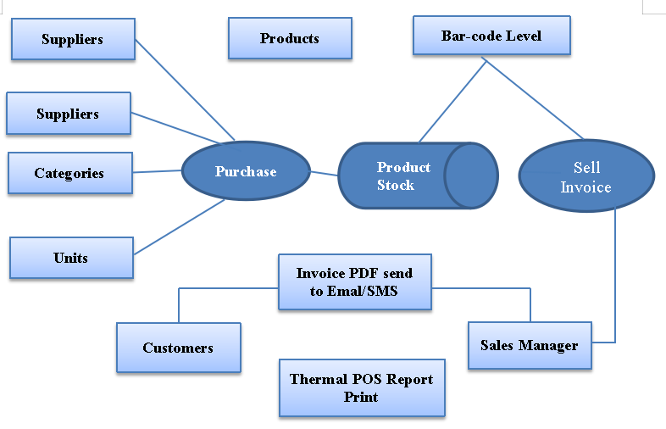
Figure 2.2: Working Process Flowchart.

2.4 Home Page Design
A thorough understanding of the needs of the final user and the different platforms that users will view the page on is essential for home page design [3]. The best ways to approach the header, navigation, content sections, sidebars, footers, and backgrounds on a web page must be understood by designers in order to better meet these needs [10].

2.5 Dashboard Design
In website administration, a dashboard is usually the control panel's index page. A dashboard is created in our product management system application software for the CSE management system so that the admin user can update the entire system at a glance. Making any business decision is aided by this [12].

2.6 User Interface Design
- Dashboard  - Daily, weekly, monthly and custom date wise total purchase, total sell, total profit.  - Quick look up for transactions details.  - Manage Supplier  - Add Supplier.  - All Supplier.  - Mange Customers  - Add Customer.  - All Customer.  - Credit Due Customer.  - Credit Paid Customer.  - Customer Wise Report.  - Manage Sales Representative (SR)  - Add SR  - All SR  - Mange Units  - Add Unit  - Units All  - Mange Category  - Add Category  - Category All  - Delivery Zone  - Add Delivery Zone.  - All Delivery Zone  - Mange Product  - Add Product  - Product All | - Manage Purchase  - Add Purchase  - Purchase All  - Approval Purchase  - Daily Purchase Report  - Manage Invoice  - Add Invoice  - Invoice All  - Approval Invoice  - Print Invoice  - Daily Invoice Report  - Delivery Zone Details  - Delivery Zone Summary  - Delivery Summary Edit  - Manage Stock  - Stock Report  - Supplier / Product Wise Report  - Manage Return  - Add Return  - Return All  - Approval Return  - Daily Return Report  - Authentication  - User Profile View  - User Profile Image Change  - Change Password  - Logout  - Setting  - Change Logo  - Change Cover Image

2.7 Tools and Technologies
To implement the project, some open source tools have been used such as,
- Programming Languages: PHP 8.1
- Framework: Laravel-10 MVC
- Scripting Language: HTML5, CSS3, Bootstrap, JavaScript, jQuery
- Database: MySQL/MariaDB
- Server: Apache/Tomcat
- API: Email/SMS integration
- Tools: XAMPP, FileZilla, PDF Generator, JavaScript Library.
- IDE: Visual Studio Code, Notepad++, PhpStrom
- Hardware: Bar-Code Scanner, POS Thermal Printer, Bar-code level printer.

Chapter 3

Object-Oriented Analysis and Design of Enterprise Product Management System

3.1 Object-Oriented Analysis and Design
Designing and developing an product management system in Laravel 10 using object-oriented analysis and design relate analysis the problem into manageable element and creating a organized structured plan for the system [8].
A crucial step in the software development life cycle, object-oriented analysis is the process of analyzing a system or problem domain to determine and understand the objects, their attributes, and their interactions. It serves as a fundamental foundation for creating object-oriented designs [11].
The main objective of object-oriented analysis is to create a conceptual model of the system that accurately represents the real-world entities and their interactions [4]. The process of analyzing a system or problem domain to identify and understand the objects, their attributes, and their interactions is known as object-oriented analysis. The process of analyzing a system or problem domain to identify and understand the objects, their attributes, and their interactions is known as object-oriented analysis. [2]

3.2 Requirements Gathering
Begin by understanding the requirements of your product management system. Gather information on what the system should do, its key features, and any specific business rules or constraints. [13]
- Use Case Diagram
Create a use case diagram to symbolize the interactions between various actors (users or admin) and the product management system. Identify the primary use cases such as adding items, updating/editing quantities, generating reports, etc [6, 7].
ii. Class Diagram
Based on the use case diagram, identify the key objects and entities within the system [7]. Create a class diagram that defines the classes, their attributes, and relationships. For example:
Class: Product, Category, Supplier, Units, Purchase, product, Invoice, User, etc.
- Object-Oriented Analysis
Use OOAD rule to analyze the behavior of the classes you've identified. Define the methods and responsibilities of each class. Consider implementing design patterns like Singleton for database connections or Factory for creating objects [8].
- Database Design
Create a database schema based on the class diagram. Define tables, columns, relationships, and constraints. Laravel provides migrations and Eloquent ORM to help with this task [6].
- User Interface Design
Design the user interfaces (UI) for different use cases. I am using diagram.io for online use. Visio for computer [5].
- Object-Oriented Design
Implement the classes defined in the class diagram using PHP and Laravel. Each class should encapsulate its data and behavior. Utilize Laravel's Eloquent ORM for defining and interacting with database models [9].
- Controller Design
Create controllers to handle the logic of your application. These controllers will receive requests from the UI, invoke the appropriate methods on your objects, and return responses.
- Routing
Define routes in Laravel to map HTTP requests to specific controller actions. Make sure to follow RESTful design principles for clean and structured routing [14].
- Views and Templates
Use Blade templates to render views and present data to users. Keep the separation of concerns in mind, and avoid placing too much logic in views [13].
- Testing
Write unit tests and integration tests to ensure that your system works as expected. Laravel's built-in testing tools make this process easier [15].
- Security
Implement security measures like validation and authorization to protect your system from unauthorized access [18].
- Documentation
Have to keep the document my code, database schema, and APIs for future reference and for other developers who may work on the project [17].
- Deployment
Deploy your Laravel application to a production live server, configure environment variables, and set up monitoring and error tracking [19].
- Maintenance
Regularly update and maintain my application, checking bugs and adding new features as needed. Laravel provides a robust framework to implement the object-oriented design principles and create a scalable and maintainable product management system [13].

3.3 Requirements Analysis
A requirements analysis process involves the following steps:
Step 1: Identify Key customer/client and End-Users
Finding the major project users, or key stakeholders, is the first step in the requirements analysis process. Regarding what belongs in the project's scope, they will have the last say. Next, determine who the product's end users are. Since the product is meant to meet their needs, their feedback is just as valuable [4, 9].
Step 2: Asking for Demand
- Find out what the end users and stakeholders need from the new product. You can obtain requirements by using the following requirements analysis techniques [7].
- Hold One-On-One Interviews
Interview every end-user and stakeholder separately. Using this method will enable me to compile precise needs [12, 13].
- Group Workshops
Perform group workshops or interviews to gain insight into the information exchanged between various end users and stakeholders. Later on in the project, this method will guarantee that there are no conflicts of interest [17].
Step 3: Understanding and Record Requirements
After the requirements have been classified, ascertain which of the requirements can actually be met and record each one. Here are some methods for interpreting and analyzing requirements [8].
Step 4: Sign off the Agreement
Get a signed agreement from the important stakeholders as soon as the requirements are decided upon. This is done to make sure the project's scope doesn't alter or grow out of control [23].

3.4 Use Case Diagram

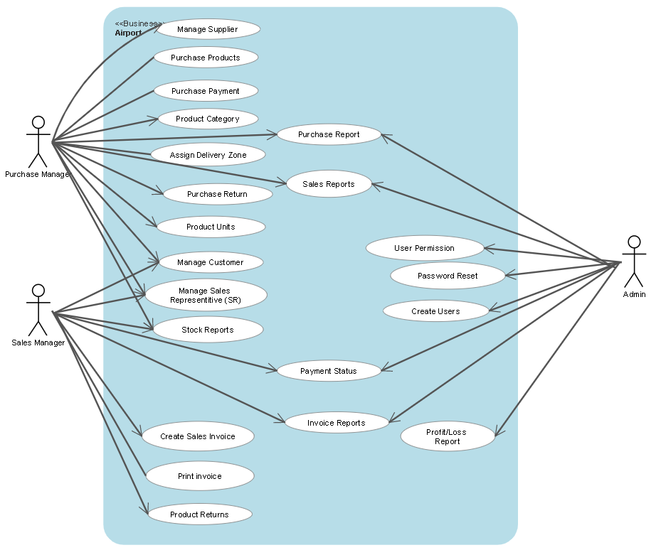
Figure 3.1: Use Case Diagram.

3.5 Class Diagram

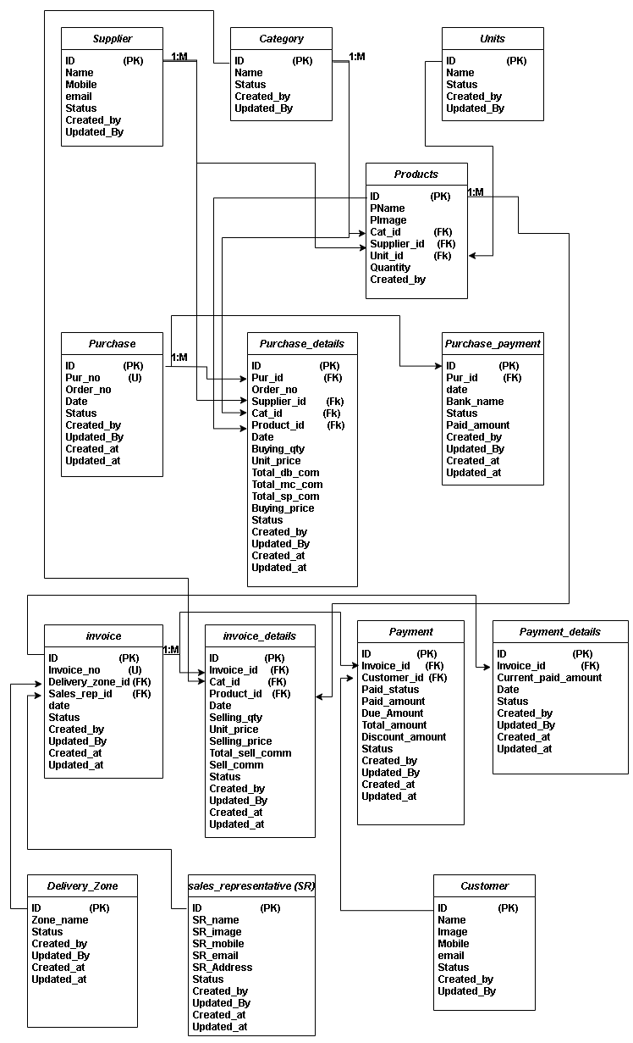
Figure 3.2: Class Diagram.

3.6 Data Flow Diagram (DFD)
- Level 0 DFD:
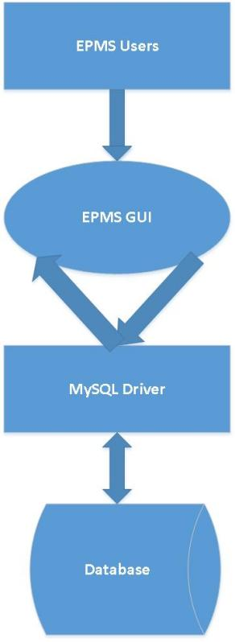
Figure 3.3: Level 0 DFD.

- Level 1 DFD:

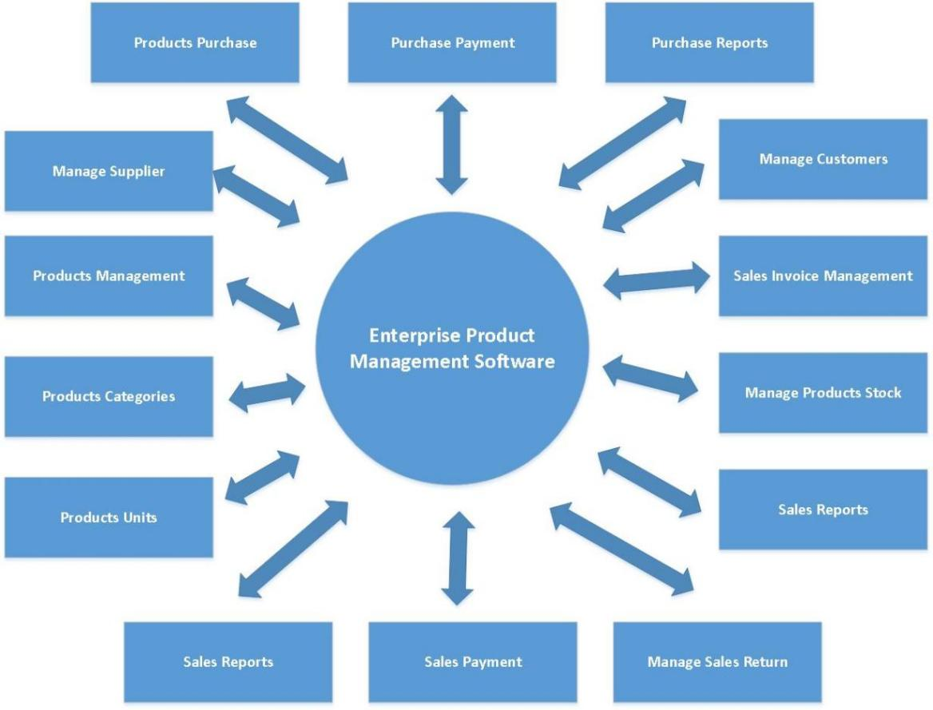
Figure 3.4: Level 1 DFD.

iii. Level 2 DFD:

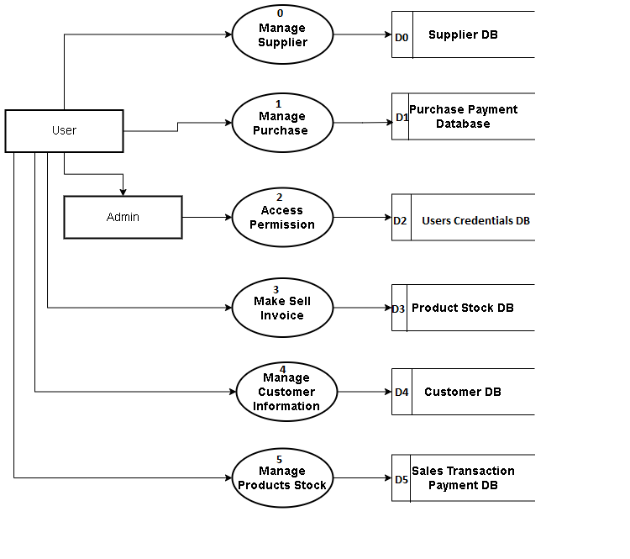
Figure 3.5: Level 2 DFD.

3.7 GUI Design

i. Laravel Framework Architecture
The Laravel is a reliable, lightweight, secure, development friendly framework. It is designed to deliver maximum performance in less time within a clean environment. That’s why I have used Laravel framework to develop this system. Architectures are following:
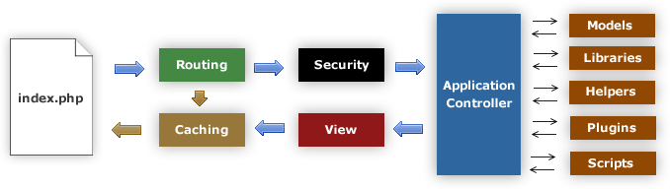
Figure 3.6: Laravel Framework Architecture.

ii. Laravel MVC Application Life Cycle:

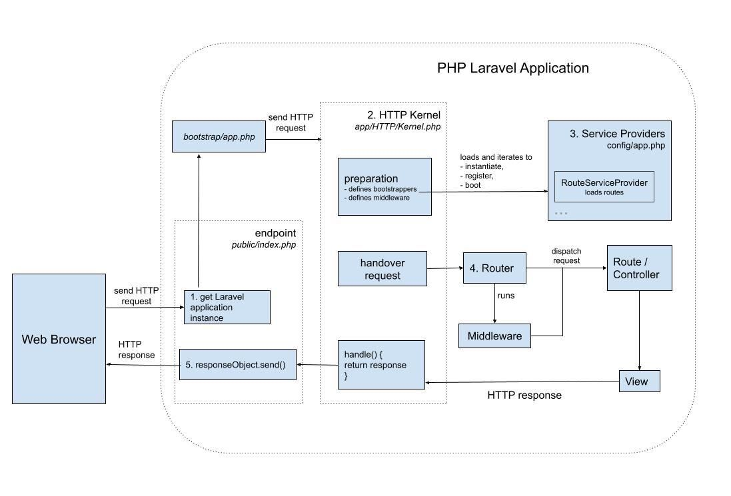
Figure 3.7: PHP Laravel Application Life Cycle.

3.8 Entity Relationship Diagram (ERD)

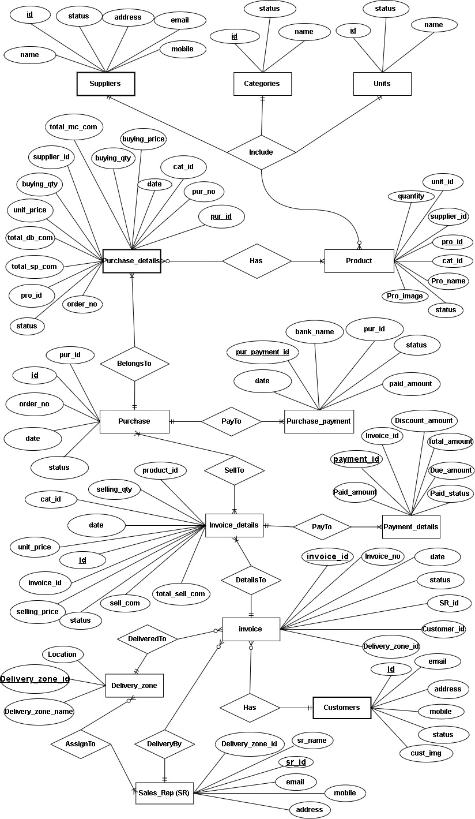
Figure 3.8: Entity Relationship Diagram.

Chapter 4

Implementation and Results

4.1 Code
Projects code are classifying some sub classes. In MVC format laravel has some files like
- Basic Command (Server Start, Database Connection)
- Main Route File
- Default Authentication file
- Model class files
- Controllers Class file
- View files

4.1.1 Apache Server Start and Connecting Database
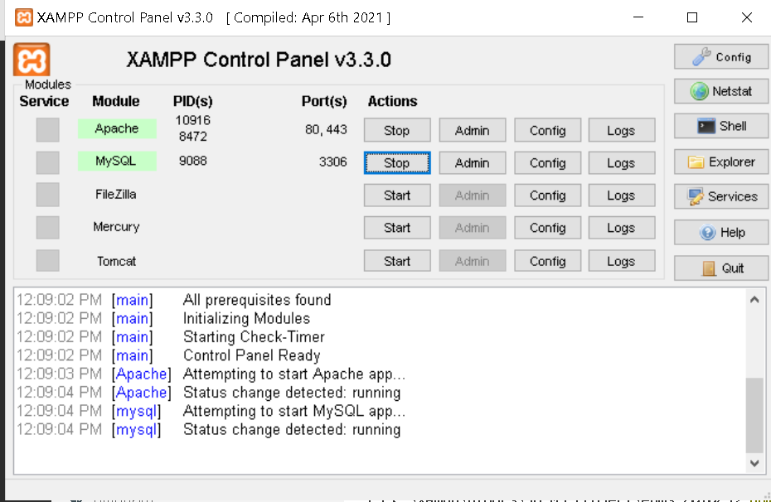
Step 1: Start XAMPP Control Panel
- Start Apache Server
- Start MySQL
Figure 4.1: XAMPP Control Panel.

Step 2: Some console command to start php server
- Php artisan serve: Start the php server with default local link.
http://localhost:8000 Or
http://127.0.0.1:800
- Npm run dev: After run this command, the server gets automatically refreshed.
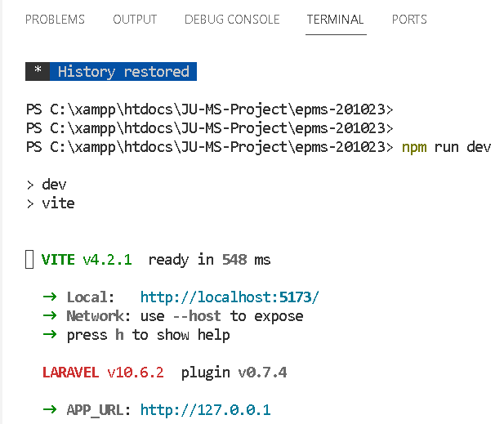
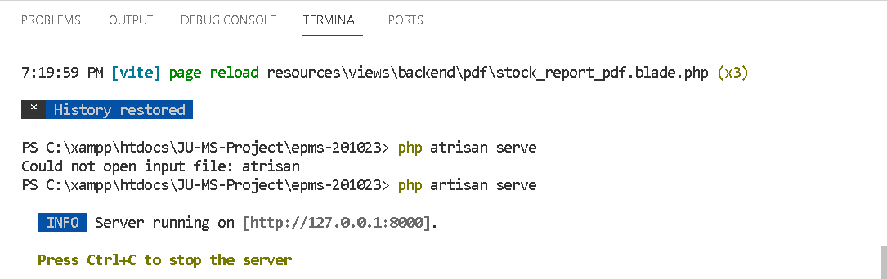

Figure 4.2: Command to Start PHP Server.

4.2 Controller Class Code

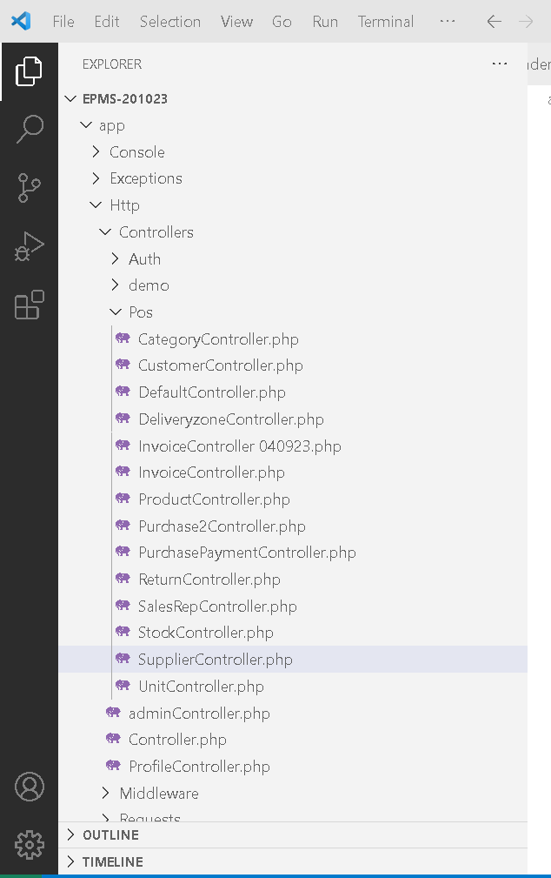
- Supplier Controller
- Category controller
- Unit Controller
- Customer Controller
- Product Contror
- Purchase Controller
- Purchase Payment Controller
- Sell Invoice Controller
- Received Customer Controller
- Sell Return
Figure 4.3: Lists of Controller Class.

4.2.1 Purchase Class Code

- Create purchase receipt
- Edit purchase receipt
- Add/Remove new item into pending purchase receipt
- Approve purchase receipt
- Delete pending purchase receipt
- Date wise purchase Report

PurchaseController.php

<?php
class Purchase2Controller extends Controller
{
// Purchase details form for show data
public function PurchaseAll(Request $request){
$allData = Purchase2::with('purchase_details.category','purchase_details.product');
if(!empty($request->purchase_id)){
$allData = $allData->where('purchase_id', $request->purchase_id);
}
if(!empty($request->end_date)){
$allData = $allData->where('date','<=', date('Y-m-d',strtotime($request->end_date)));
}
$allData = $allData->orderBy('id','DESC')->get();
// dd($allData);
return view('backend.purchase2.purchase_all',compact('allData'));

}
// Purchase insert form
public function PurchaseAdd(){
$product = Product::get();
$supplier = Supplier::get();
$category = Category::get();
return view('backend.purchase2.purchase_add',compact('product','supplier','category'));
}//End Method

function PurchaseEdit(Request $request, $id){
$purchase = Purchase2::with('purchase_details.category','purchase_details.product')->findOrFail($id);
$product = Product::get();
$supplier = Supplier::get();
$category = Category::get();
if($purchase->status == 1){
$notification = array(
'message' => 'Already Approved.',
'alert-type' => 'error'
);
return redirect()->route('purchase2.all')->with($notification);
}
return view('backend.purchase2.edit',compact('purchase','product','supplier','category'));
}
// Purchase item save to Database
public function PurchaseStore(Request $request ){
if($request->category_id== null ){
$notification = array(
'message' => 'Sorry you do not select any Item.',
'alert-type' => 'error'
);
return redirect()->back()->with($notification);
}
else{
$purchase = new Purchase2;
$purchase->created_by =auth()->id();
$purchase->save();
for($i = 0; $i < count($request->category_id); $i++){
$purchase_details = new purchasDetails;
$purchase_details->purchase_id = $purchase->id;
$purchase_details->order_no = $purchase->id;
………………………………………………..
………………………………………………..
$purchase_details->created_by = auth()->id();
$purchase_details->created_at = Carbon::now();
$purchase_details->save();
} // end of else
} // end of For loop
return redirect()->route('purchase2.all')->with($notification);
}//End Method

// Purchase Delete from database
public function PurchaseDelete($id){
$purchase = Purchase2::findOrFail($id);

if($purchase->status == '0'){
Purchase2::findOrFail($id)->purchase_details()->delete();
Purchase2::findOrFail($id)->delete();
}
return redirect()->back()->with($notification);
}//End Method

public function PurchaseDetails(Request $request, $id){
$purchase = Purchase2::with('purchase_details.category','purchase_details.product')->findOrFail($id);
return view('backend.purchase2.purchase_details',compact('purchase'));
}
public function PaymentStatusUpdate(Request $request) {
$this->validate($request,[
'id' => 'required|integer|min:1',
'purchase_id' => 'required|integer|min:1',
'status' =>'required|in:Approved,Void'
]);
$payment = PurchasePayment::where([
['id',$request->id],
['purchase_id',$request->purchase_id],
['status',"Pending"]
])->first();

if($payment && in_array($request->status,['Approved','Void'])){
$purchase = Purchase2::with('purchase_details','purchase_payment')->where([
['id',$request->purchase_id],
['status',1]
])->first();
$due = $purchase->purchase_details->sum('buying_price') - $purchase->purchase_payment->where('status',"Approved")->sum('paid');
if($due > 0 && $payment->paid <= $due){
$payment->status = $request->status;
}else{
if($request->status=='Void'){
$payment->status = $request->status;
if($payment->save()){
return response()->json($notification);
}
}
return response(['error',303]);
}
}
}
// Purchase pending page
public function PurchasePending(){
$allData = Purchase::orderBy('date','desc')->orderBy('id','desc')->where('status','0')->get();
return view('backend.purchase2.purchase_pending',compact('allData'));
}//End Method

// Purchase Approval
public function PurchaseApprove($id){
$purchase = Purchase2::with('purchase_details')->findOrFail($id);
if($purchase->status == 1){
return redirect()->route('purchase2.all')->with($notification);
}
if($purchase->purchase_details->count()>0){
foreach($purchase->purchase_details as $purchase_details){
$product = Product::where('id', $purchase_details->product_id)->first();
$purchase_qty = ((float)( $purchase_details->buying_qty)) + ((float)($product->quantity));
$product->quantity = $purchase_qty;
$product->save();
}
}
$purchase->status = 1;
if($purchase->save()){
return redirect()->route('purchase2.all')->with($notification);
}
}//End Method
}

4.2.2 Sell Invoice Class Code

- Create sell invoice
- Edit sell invoice
- Add/Remove new product into pending sell invoice
- Approve sell invoice
- Delete pending sell invoice
- Date wise sell invoice Report

InvoiceController.php
<?php
class InvoiceController extends Controller
{
// Invoice Show Data
public function InvoiceAll(){
// $allData = Invoice::orderBy('date','desc')->orderBy('id','desc')->where('status','1')->get();
$allData = Invoice::orderBy('date','desc')->orderBy('id','desc')->get();
return view('backend.invoice.invoice_all',compact('allData'));
} //End Method
// Invoice insert form
public function InvoiceAdd(){
$category = Category::all();
$customer = Customer::all();
$payment = Payment::all();
$invoice_data = Invoice::orderBy('id','desc')->first();
if($invoice_data == null){
$firstReg = '0';
$invoice_no = $firstReg + 1;
}
else{
$invoice_data = Invoice::orderBy('id','desc')->first()->invoice_no;
$invoice_no = $invoice_data + 1;
}
$date = date('Y-m-d');
return view('backend.invoice.invoice_add',compact('invoice_no','category','date','customer','payment'));
}//End Method
else{
$invoice = new Invoice();
$invoice->invoice_no = $request->invoice_no;
$invoice->date = date('Y-m-d', strtotime($request->date));
$invoice->description = $request->description;
$invoice->status = '0';
$invoice->delivery_zone_id = $request->delivery_zone_id;
$invoice->sales_rep_id = $request->sales_rep_id;
// For using partial table insertion if error others table
DB::transaction(function() use($request, $invoice){
if($invoice->save()){
// Invoice form data save to Invoice details table
$count_category = count($request->category_id);
for($i = 0; $i < $count_category; $i++){
…………………………………………..
…………………………………………..
$invoice_detail->total_sell_commission = $request->sell_commission_total[$i];
$invoice_detail->status = '0';
$invoice_detail->created_at = Carbon::now();
$invoice_detail->save();
} // end of For loop
// For Customer Insertion If select New Customer Option when Customer_id = 0
if($request->customer_id == '0'){
$customer = new Customer();
$customer->name = $request->name;
$customer->save();
$customer_id = $customer->id; }
else{
$customer_id = $request->customer_id;
}

// Payment and PaymentDetail table insertion
$payment = new Payment();
if($request->paid_status == 'full-paid'){
$payment->paid_amount = $request->estimated_amount;
$payment->due_amount = '0';
$payment_details->current_paid_amount = $request->estimated_amount;
}
elseif($request->paid_status == 'full-due' ){
$payment->paid_amount = '0' ; }
else{
$payment->paid_amount = $request->paid_amount;
$payment_details->current_paid_amount = $request->paid_amount;
}
$payment->save();
$payment_details->invoice_id = $invoice->id;
$payment_details->date = date('Y-m-d', strtotime($request->date));
$payment_details->save();
} // End of First IF
});
return redirect()->route('invoice.pending.list')->with($notification);
} // End of 2nd Else

4.3 Model class files
- Supplier model class
- Category model class
- Units model class
- Products model class
- Customer model class
- Sales Representative model class
- Delivery Zone model class
- Purchase model class
- Purchase Payment model class
- Sell Invoice model class
- Invoice Payment model class
- Sales Return model class
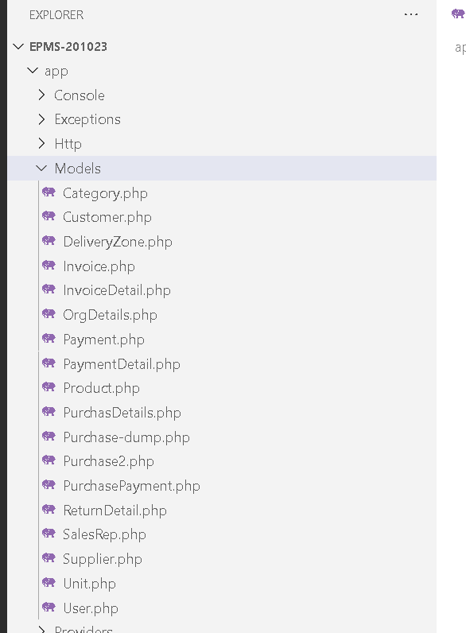
Models classes are used for database relations like one to one, one to many and many to many.

Figure 4.4: Lists of EPMS Model.

4.4 Database Tables Structure

Tables are created after the laravel migration command
- Php artisan migrate

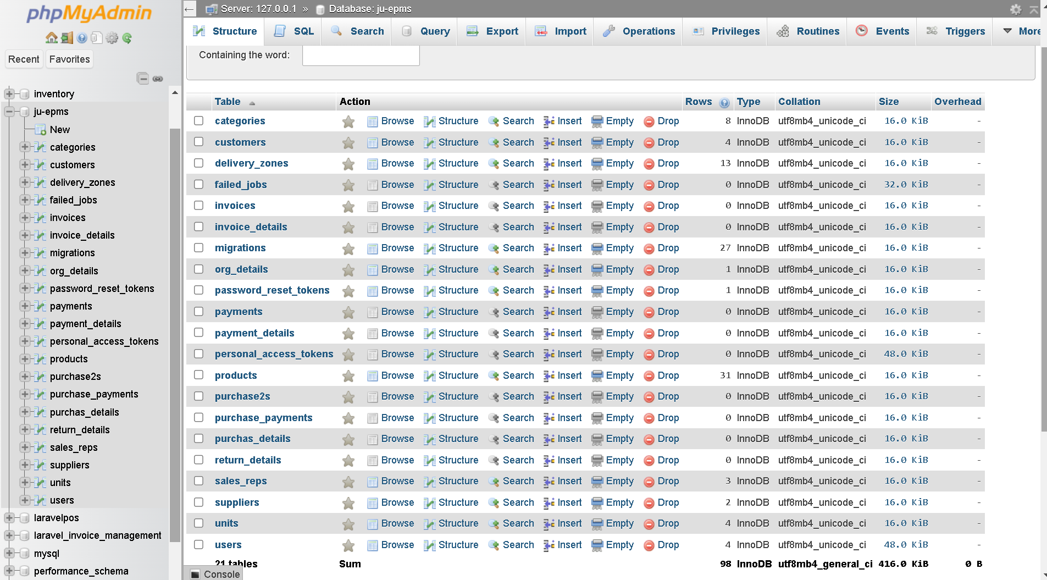
Figure 4.5: PHP MySQL Database Tables Lists.

4.4.1 Users Tables Structure

Some key filed of this tables are below.
Id: Primary key
Username: Should be unique and needed to login.
Email: Verified email are used for password reset and login
Password: Encrypted the password by hash function, there is no options to see the plan text password.
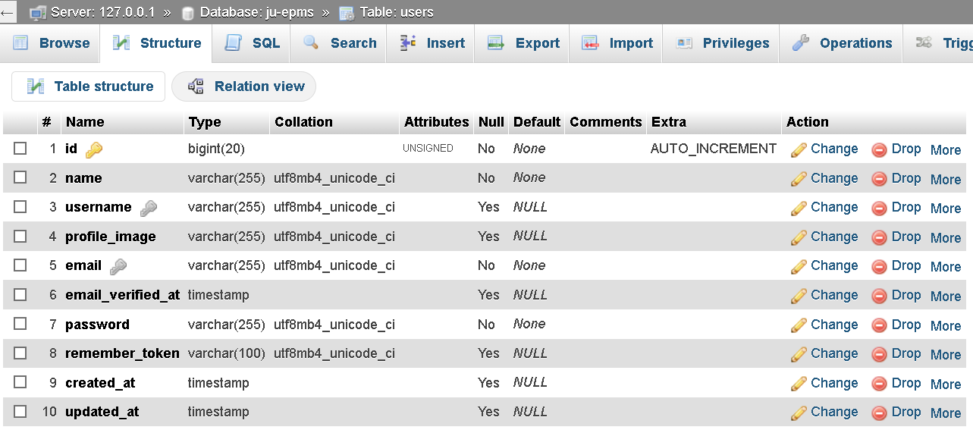
Figure 4.6: Users Tables Structure.

4.4.2 Supplier Table Structure

ID: Primary key
Status: 1 or 0, used for active or inactive.

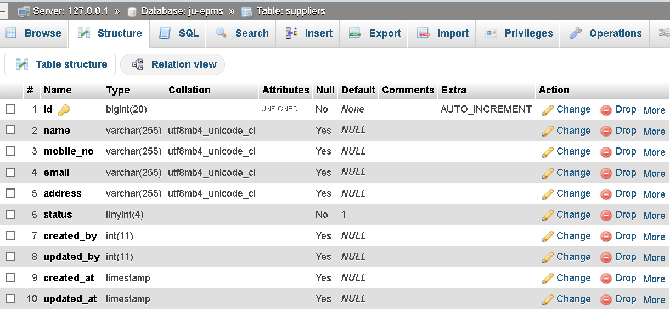
Figure 4.7: Supplier Tables Structure.

4.4.3 Category Table Structure

ID: Primary key
Status: 1 or 0, used for active or inactive.

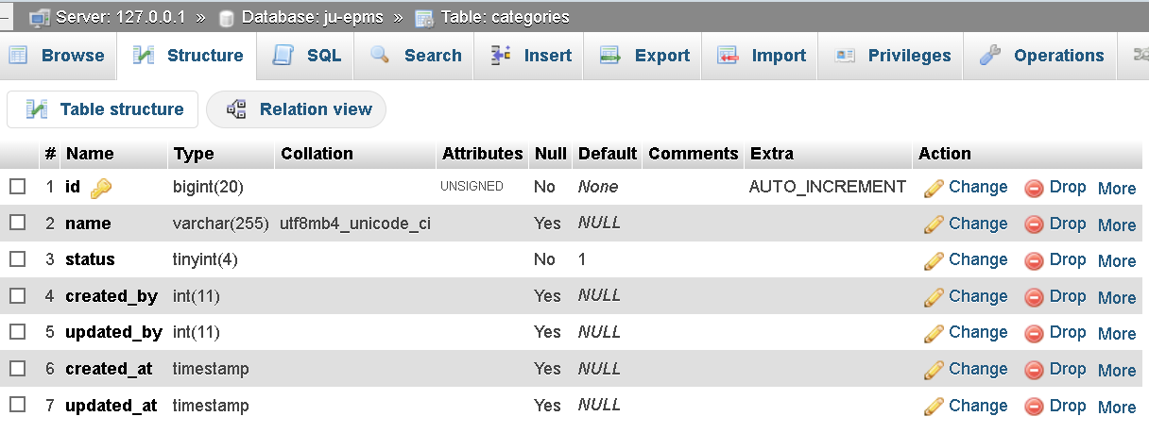
Figure 4.8: Category Tables Structure.

4.4.4 Units Table Structure
ID: Primary key
Status: 1 or 0, used for active or inactive.

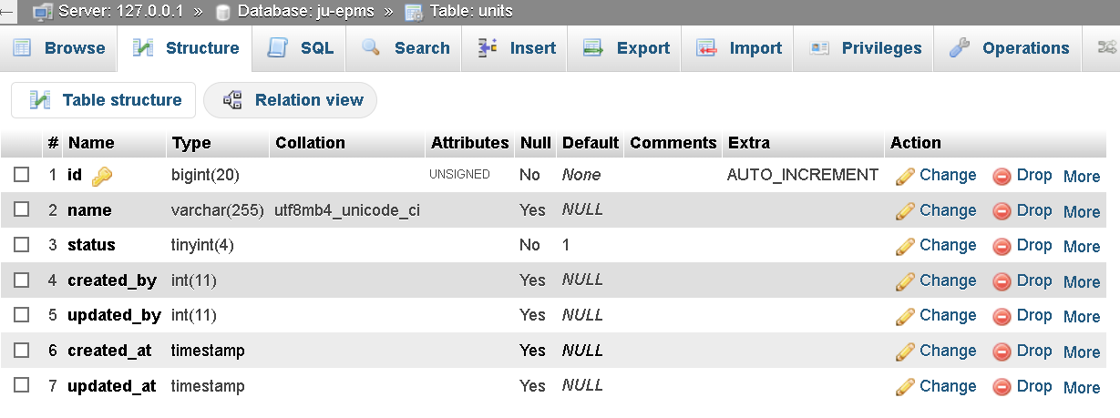
Figure 4.9: Units Tables Structure.
4.4.5 Customers Table Structure
- ID: Primary key
- Status: 1 or 0, used for active or inactive.
- Customer_image: Profile image for customer

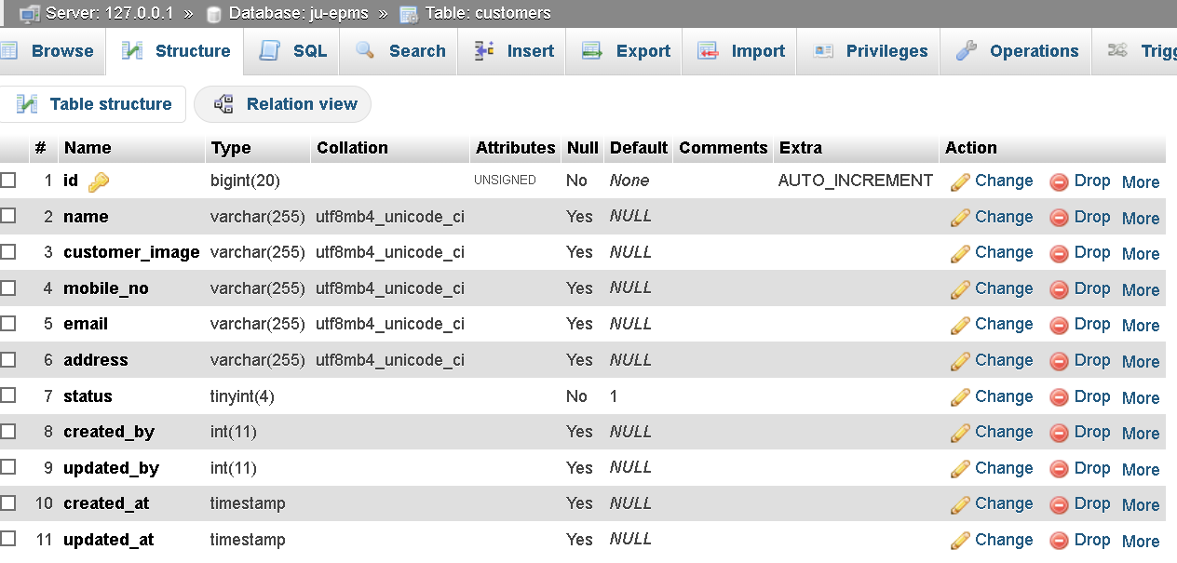
Figure 4.10: Customer Tables Structure.
4.4.6 Product Table Structure
- ID: Primary key
- Supplier_id: Foreign key
- Unit_id: Foreign key
- Status: 1 or 0, used for active or inactive.
- Product_image: Product image for viewing product

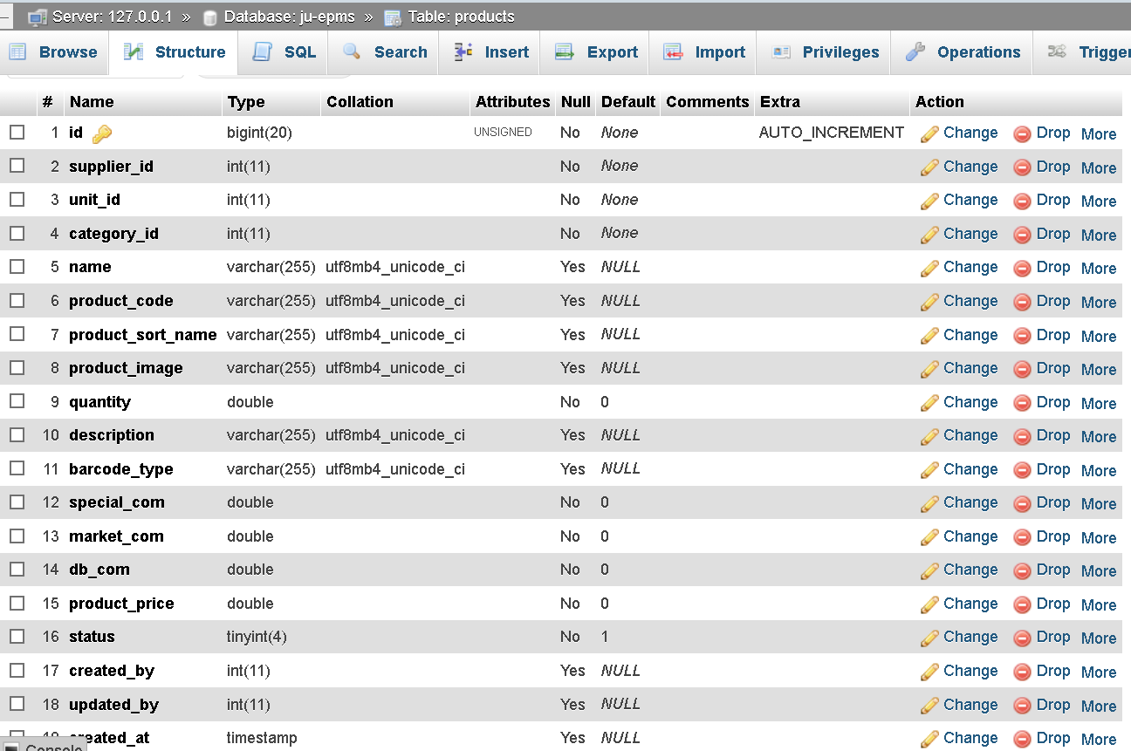
Figure 4.11: Products Tables Structure.

4.4.7 Purchase Table Structure
- ID: Primary key
- Purchase_id: Unique key
- Status: 0 for pending, 1 for approval
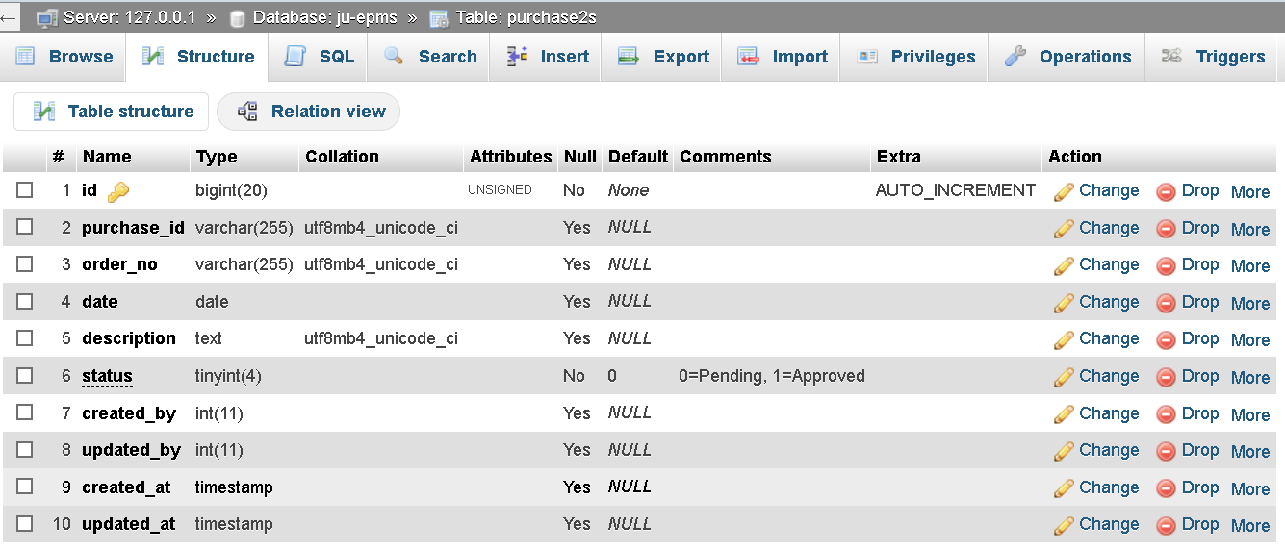
Figure 4.12: Purchase Tables Structure.

4.4.8 Purchase Details Table Structure
- ID: Primary key
- Purchase_id: Foreign key
- Status: 0 for pending, 1 for approval
- Supplier_id: Foreign key
- Category_id: Foreign key
- Product_id: Foreign key
- DB_commission: Percentage calculation of total amount multiplying by Product quantity and Product price.
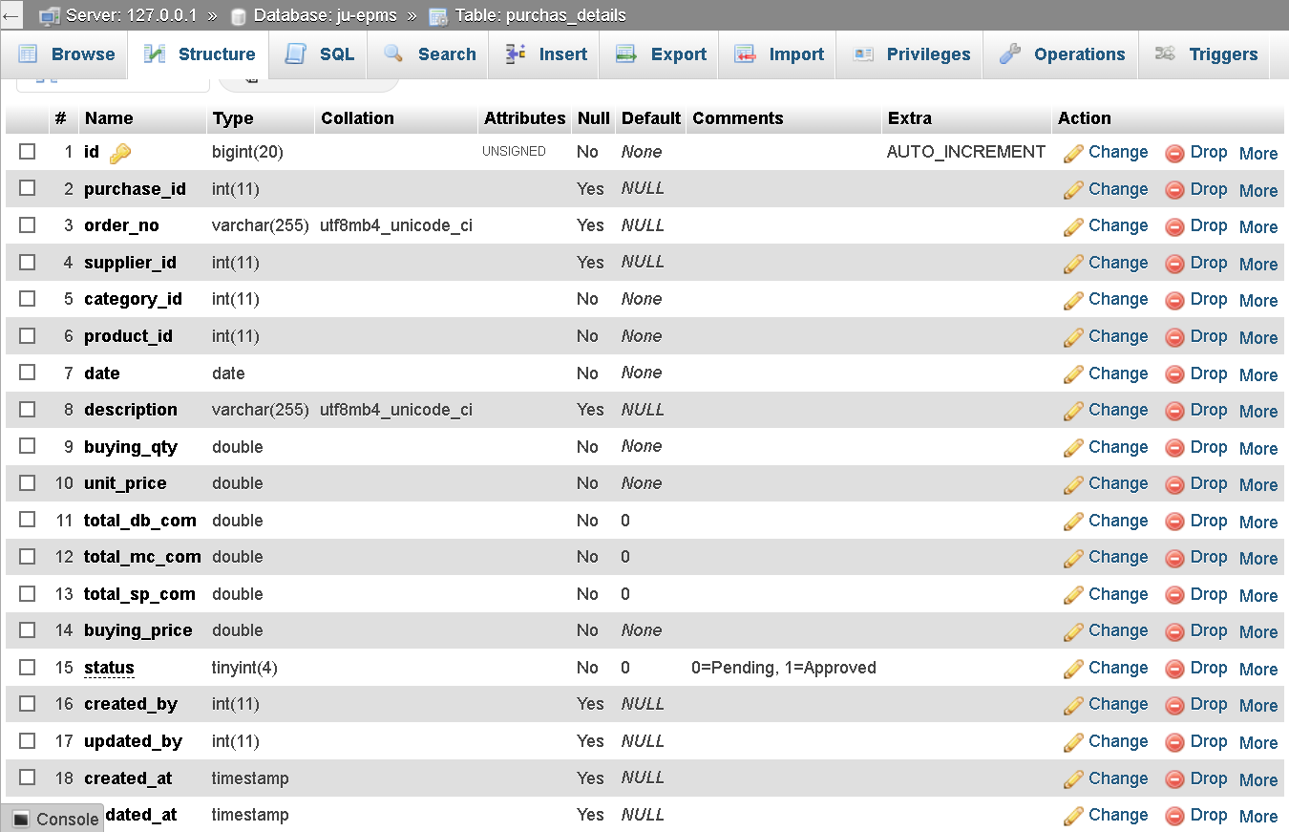
Figure 4.13: Purchase Details Tables Structure.

4.4.9 Purchase Payment Table Structure
- ID: Primary key
- Paid: Paid amount deducted from total due.

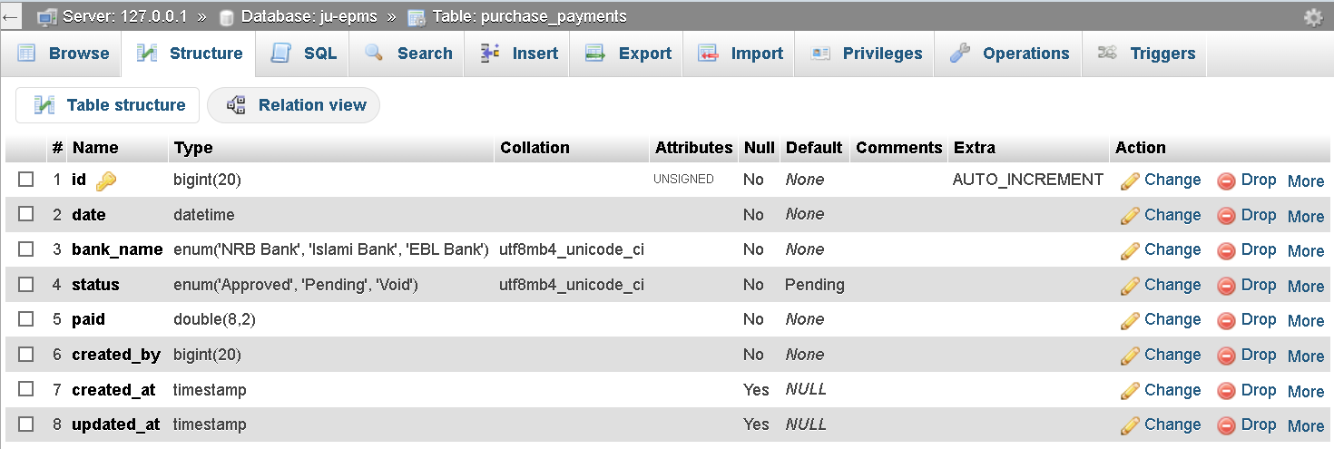
Figure 4.14: Purchase Payment Tables Structure.

4.4.10 Sales Invoice Table Structure
- ID: Primary key
- Invoice_no: Unique id
- Delivery_zone_id: Foreign Key
- Sales_Representative_id: Foreign key
- Status: 0 for pending, 1 for approval

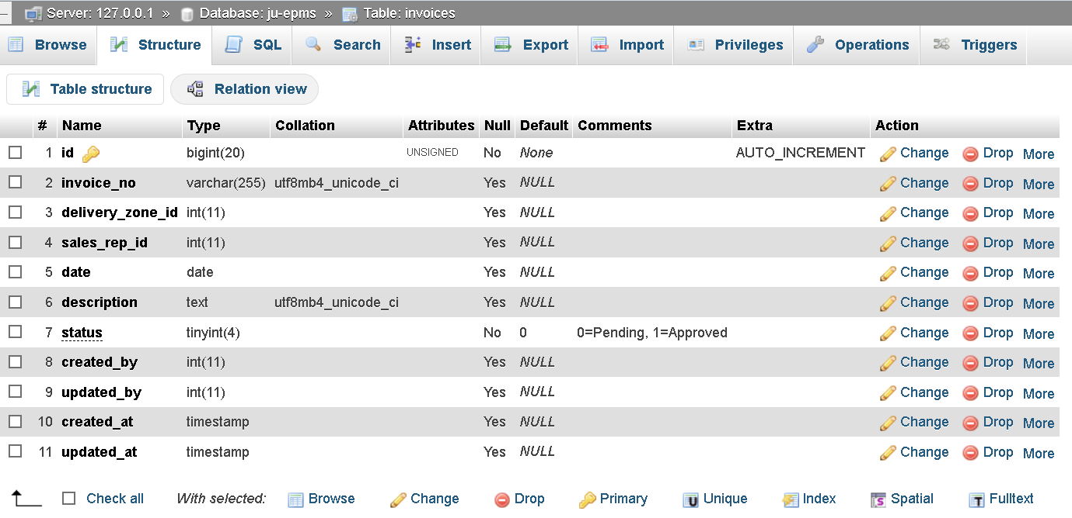
Figure 4.15: Sales Invoice Tables Structure.

4.4.11 Sales Invoice Details Table Structure

- ID: Primary key
- invoice_id: Foreign key
- Status: 0 for pending, 1 for approval
- Supplier_id: Foreign key
- Category_id: Foreign key
- Product_id: Foreign key
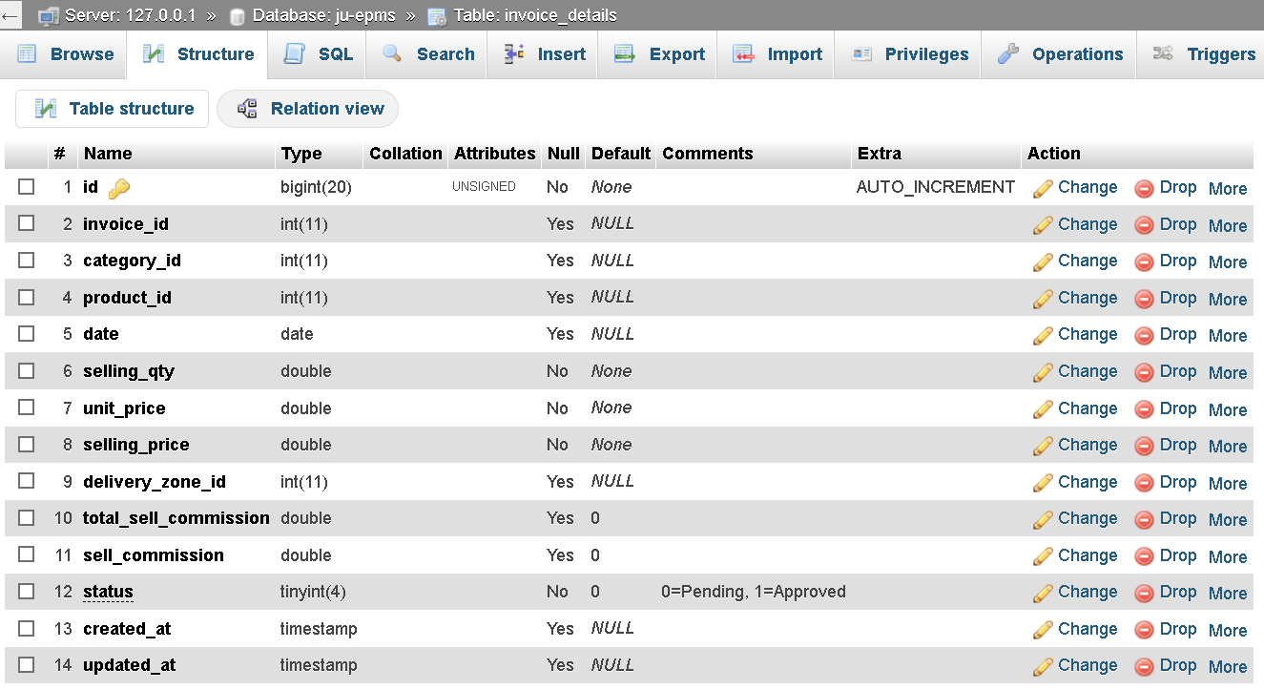
Figure 4.16: Sales Invoice Details Tables Structure.

4.4.12 Sales Payment Table Structure

- ID: Primary key
- Supplier_id: Foreign key
- Category_id: Foreign key
- Invoice_no: Foreign key
- Customer_id: Foreign_key
- Paid_Status: 0 for pending, 1 for approval

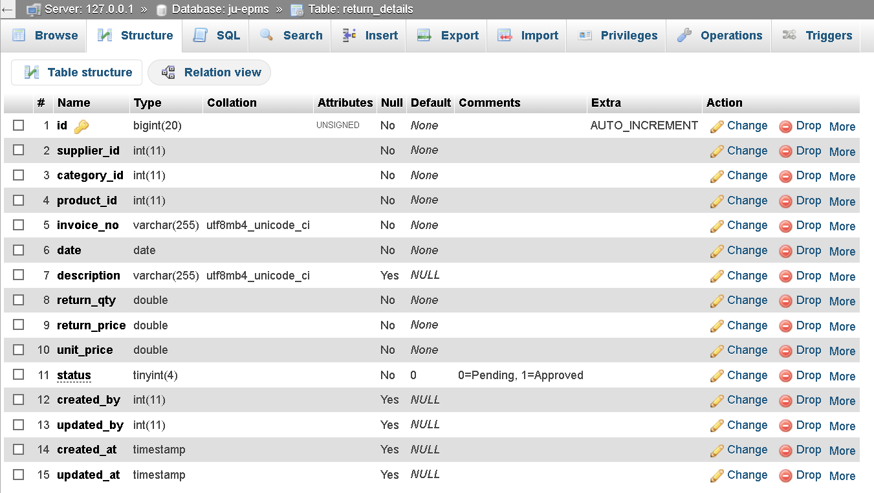
Figure 4.17: Sales Payment Details Tables Structure.

4.5 Graphical User Interface (GUI)

- User Registration
- User login interface
- Password Reset interface
- User Dashboard
- Supplier add/remove/update Interface
- Units add/remove/update interface
- Category add/remove/update interface
- Product Details add/remove/update Interface
- Purchase Receipt
- Purchase Payment
- Sales Invoice
- Sales Payment

4.5.1 User Registration

- Create new user
- Verified by Email
- Unique Username and email check authentication
- Password length minimum 6 digit
- Retype the same password

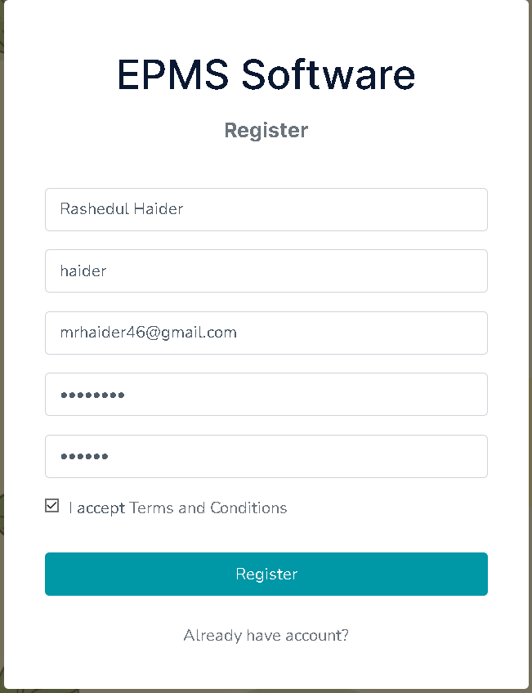
Figure 4.18: User Registration Form.
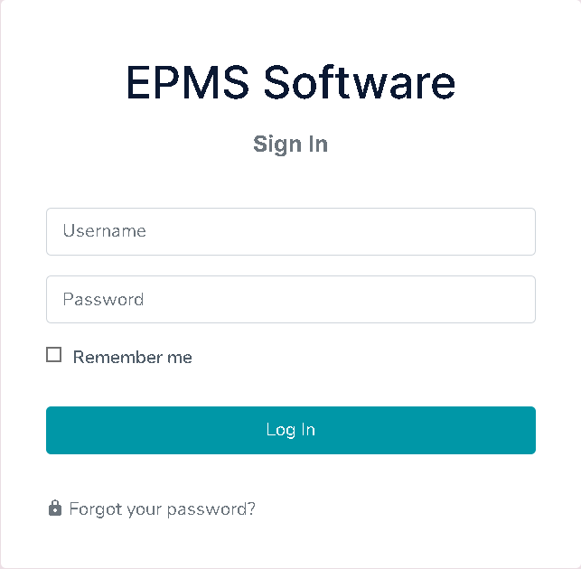
4.5.2 Login Panel

- Username
- Password

Figure 4.19: Login form.

4.5.3 Dashboard
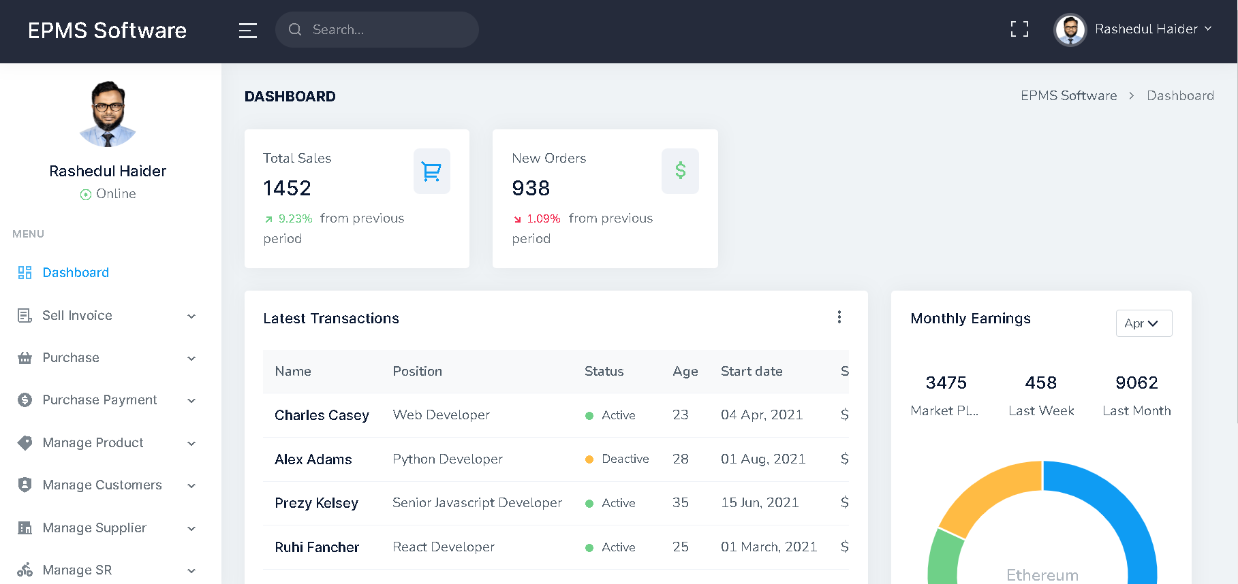
- Menu Bar
- Company Logo
- User Name
- User Profile image
- Top Bar
- User update button
- Basic information
- Footer
Figure 4.20: User Dashboard.

4.5.4 User Information update
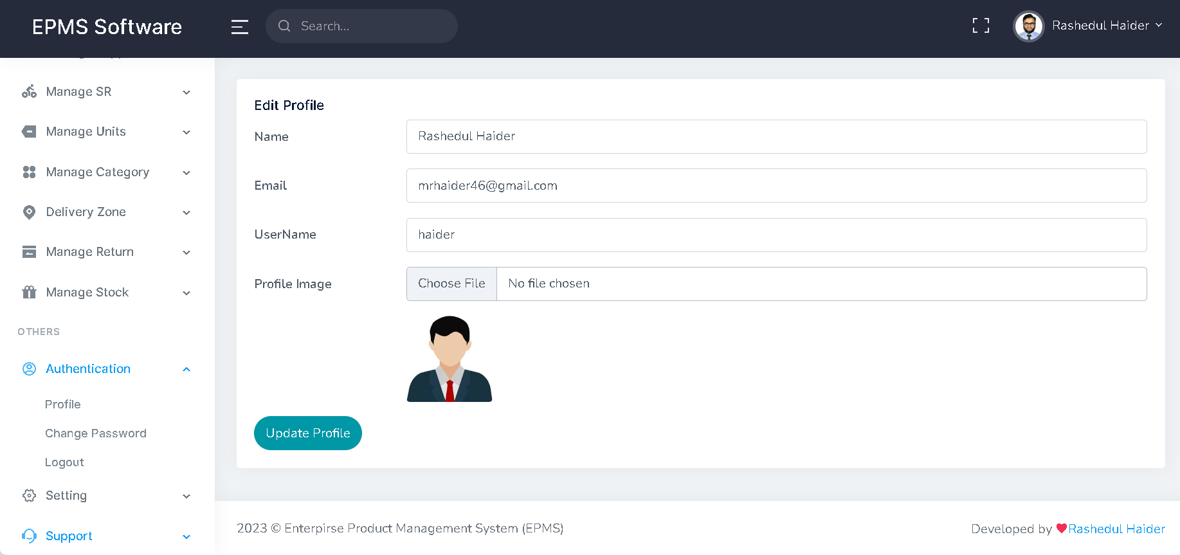
- Profile picture update
- Password update
- Email change
- Name Update
- Login Username update

Figure 4.21: User Information Update.

4.5.5 User Password Update
- Type old password
- New password
- Confirm password
- Change password button

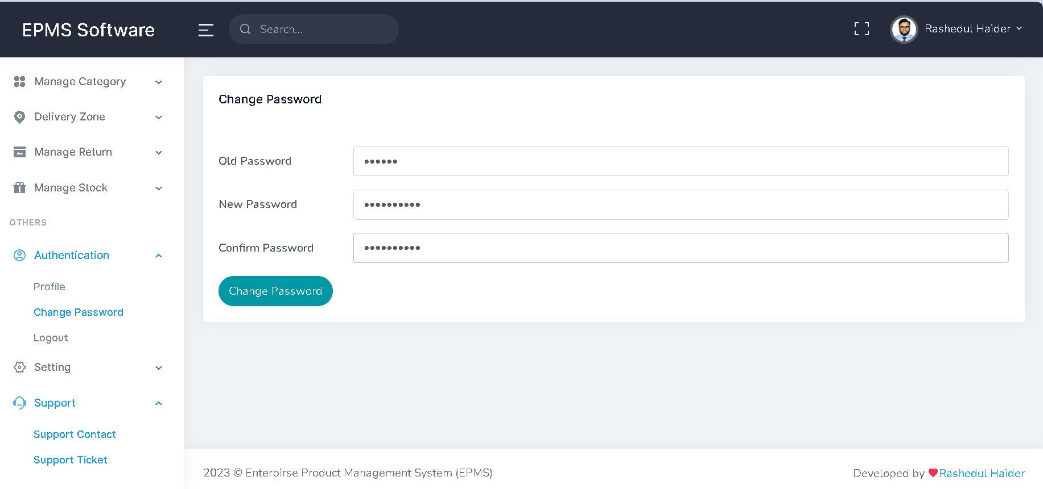
Figure 4.22: User Password Update.

4.5.6 Forget Password
Step 1: Provide your valid Email to authenticate
Step 2: Sent a Verification link to the Email
Step 3: Go to Email and validate the link
Step 4: Set a new password

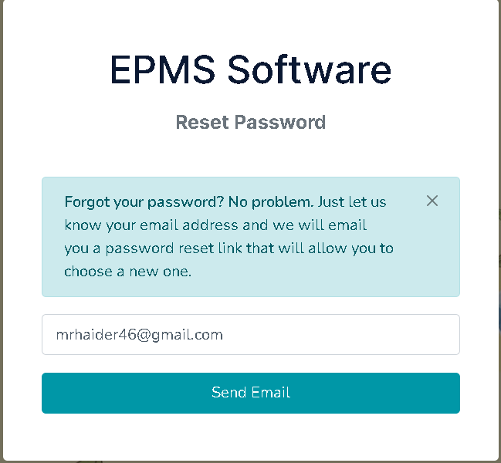
Figure 4.23: User Forget Password Form.

4.5.7 Forget Password Verification link

Step-1: Here is the email verification link for reset the password. After clicking the reset password button or verification link than it will be redirected to the set the new password form.

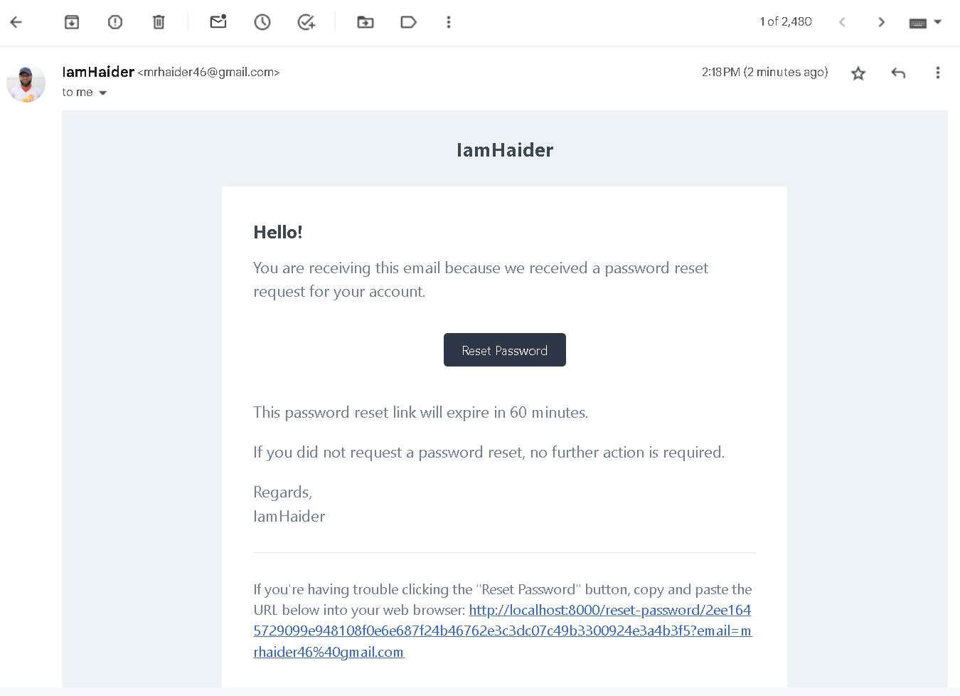
Figure 4.24: Password Reset Verification Link On Email.

Step-2: After clicking verification link redirected to set the new password form

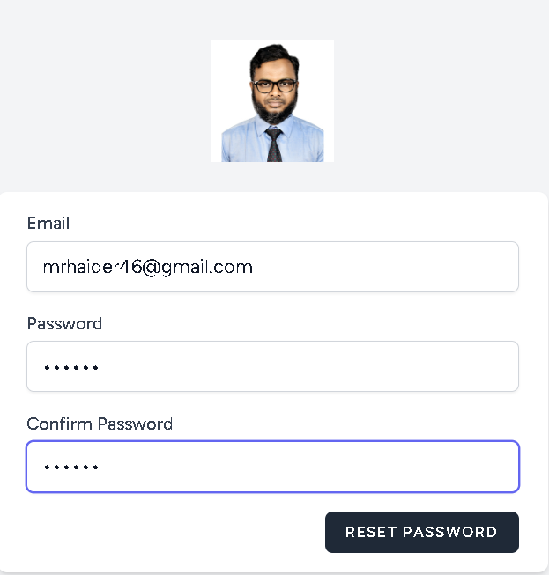
Figure 4.25: Set New Password Form.

4.6 Menu Bar

All of the menu links are showing the left menu bar. And redirected to the individual view page as per route file.

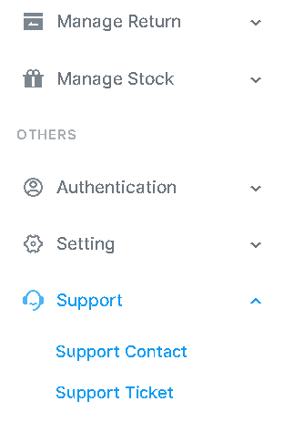
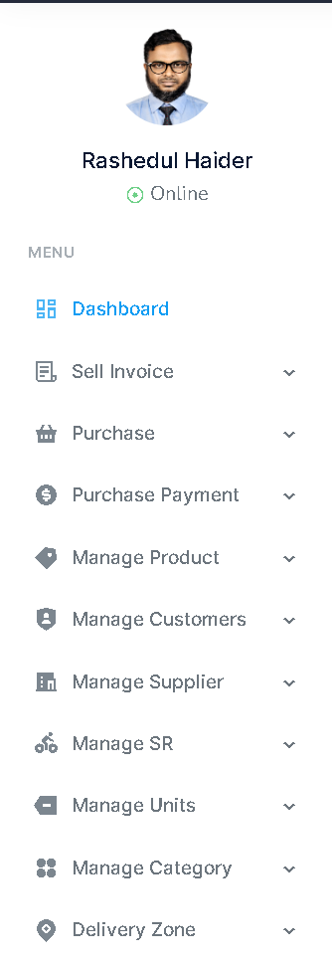
Figure 4.26: Menu Bar.
    - Supplier Interface

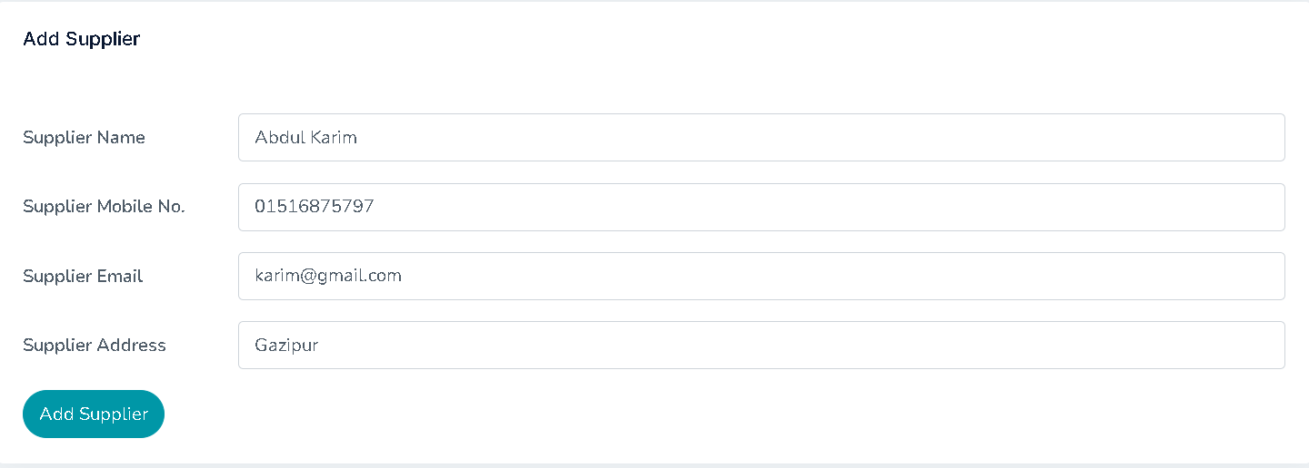
Step 1: Add supplier

Figure 4.27: Supplier Add Interface.

Step 2: All supplier data are showing with some button Add Supplier, update and delete.

- Update supplier
- Delete supplier

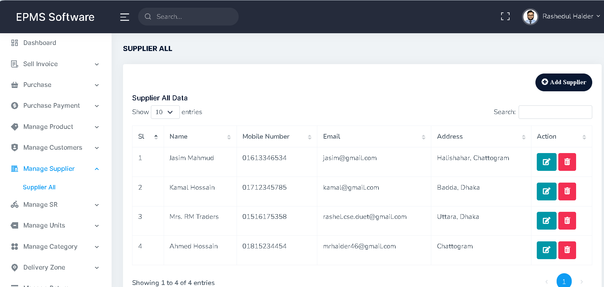
Figure 4.28: All Supplier Data Interface.

4.6.2 Category Interface

Step 2: Add Category

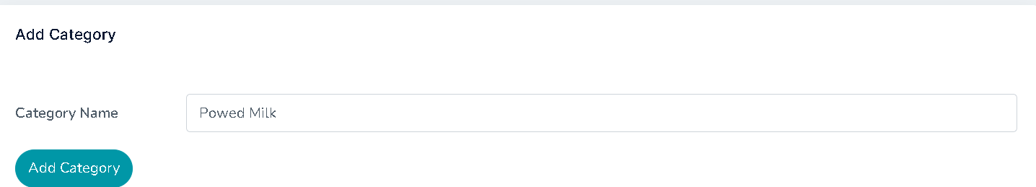

Step 2:
- Update Category
- Delete Category
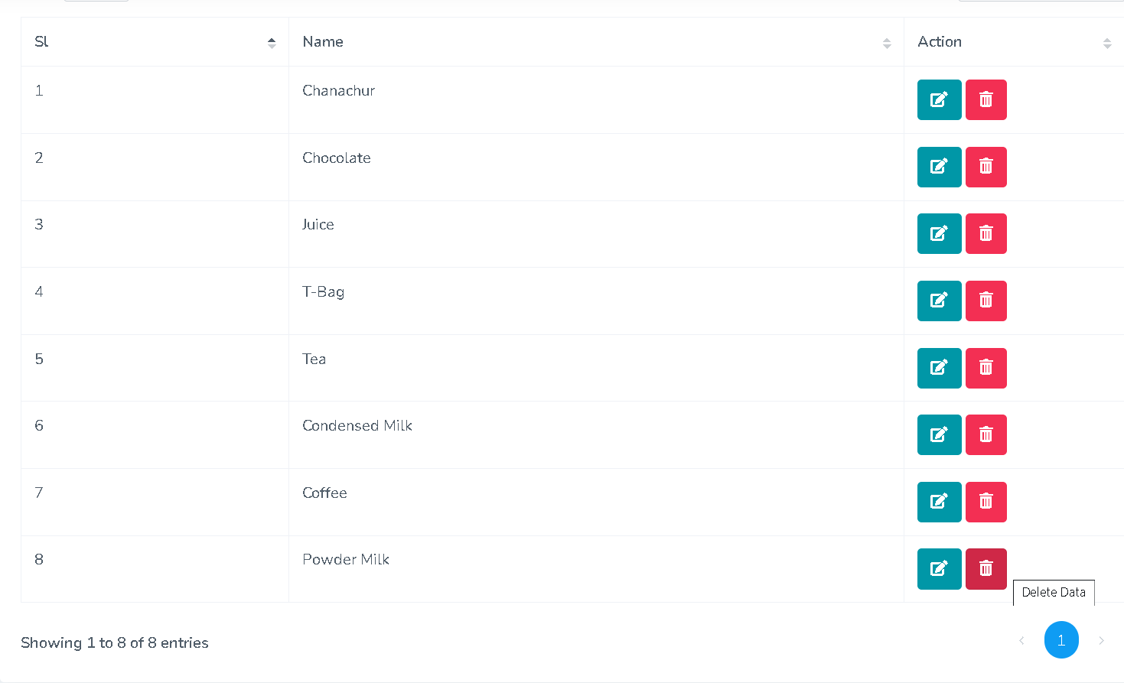
Figure 4.29: Category Form.

4.6.3 Units Interface
Step 1: Add Units
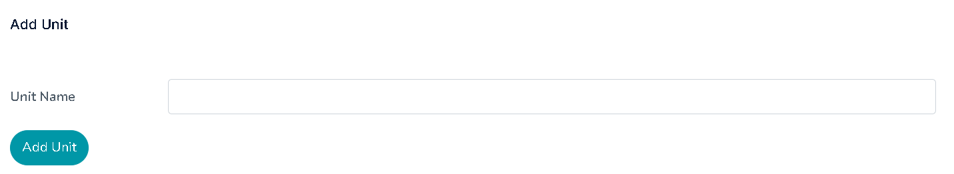

Step 2:
- Update Category
- Delete Category
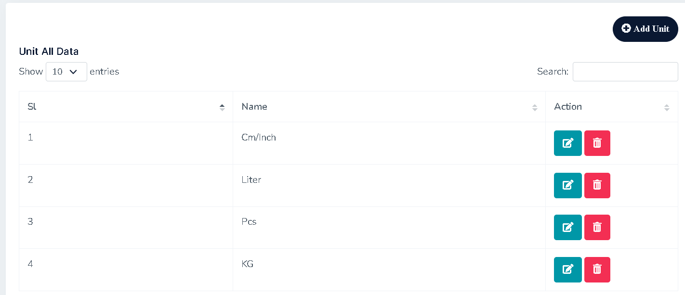
Figure 4.30: Units Form.

4.6.4 Product Interface
Step 1: Add Product Details

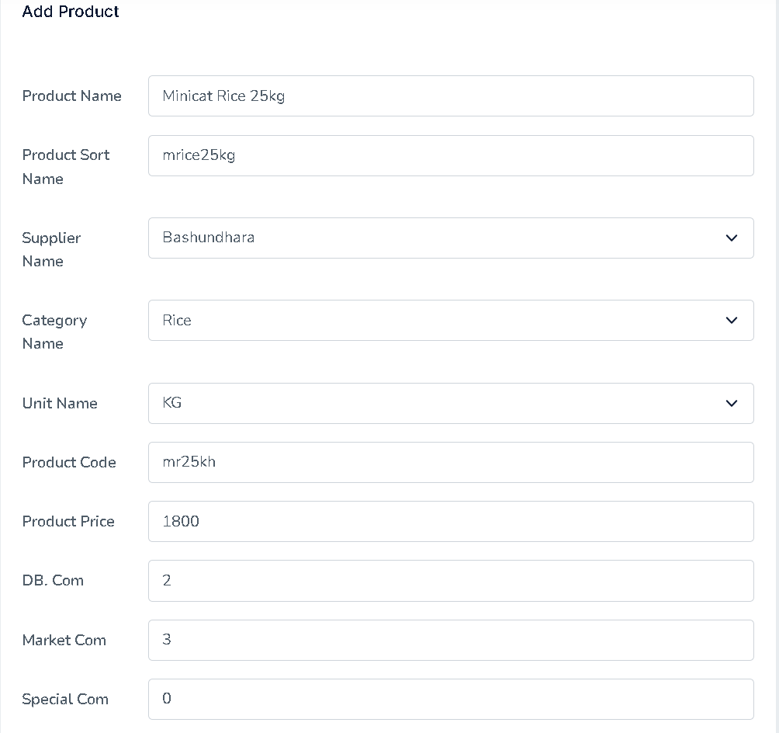
Figure 4.31: Add Products Form.

Step 2:
- View Product
- Update Product
- Delete Product

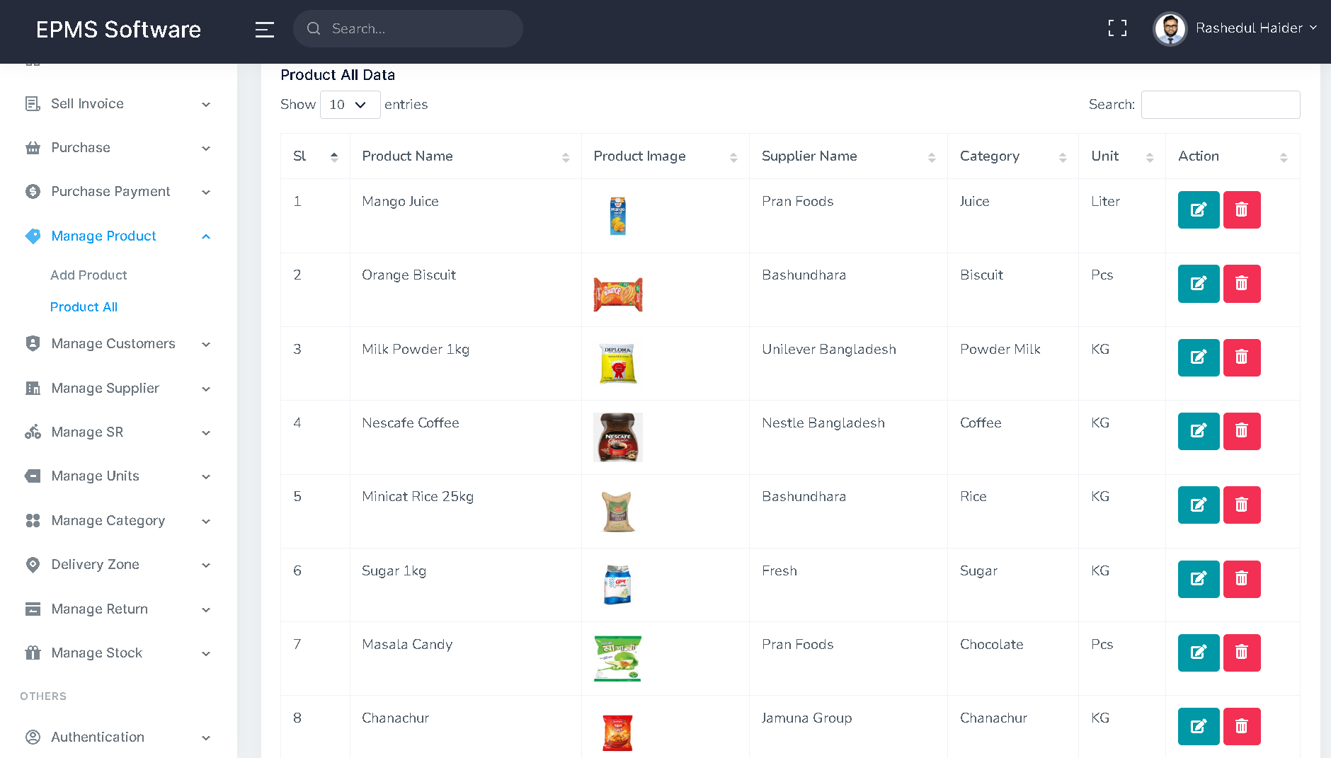
Figure 4.32: All Products Details

4.6.5 Customer Interface
Step 1: Add Customer Details

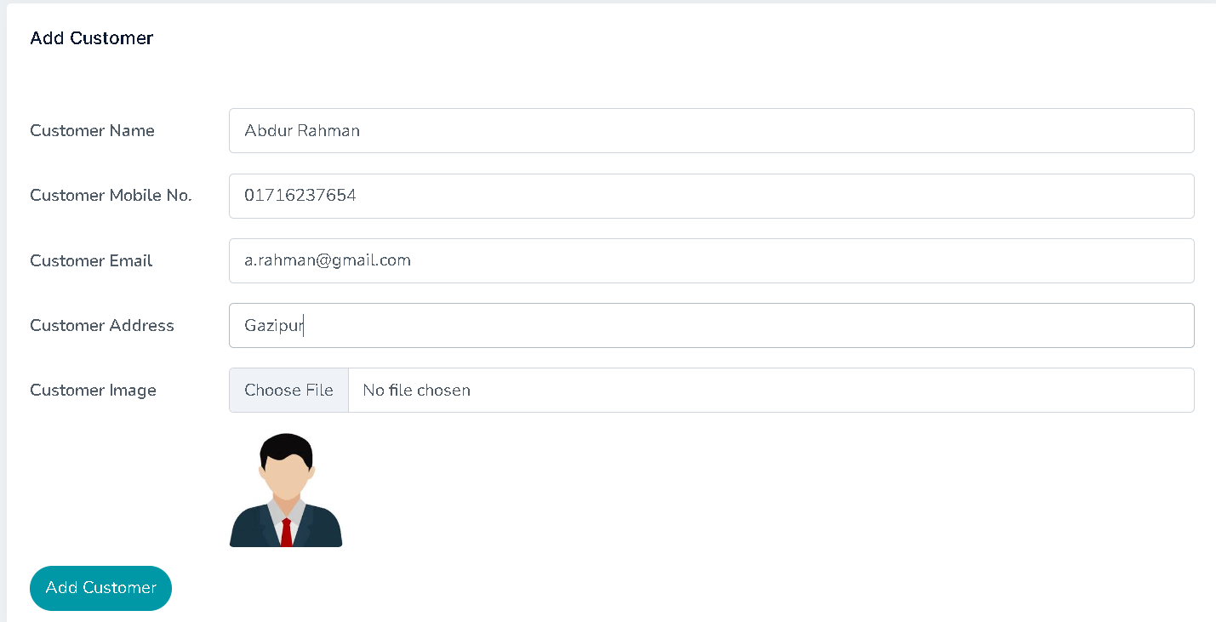

Step 2:
- View Product
- Update Product
- Delete Product
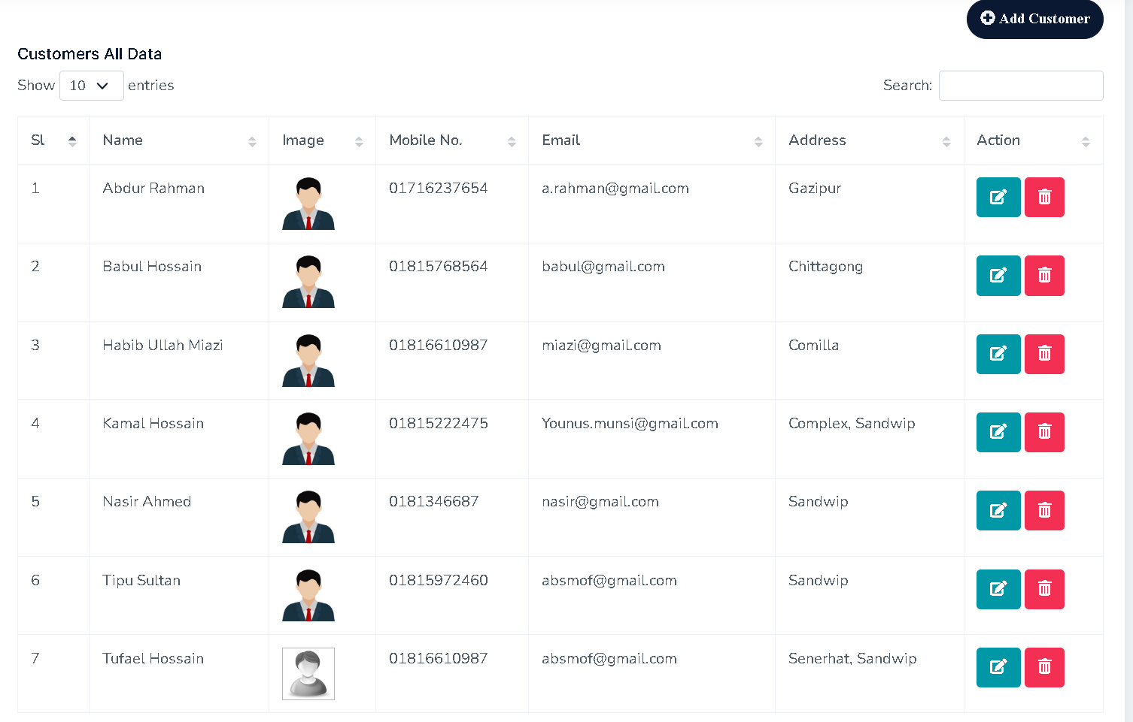
Figure 4.33: Customer Details Form.

4.6.6 Customer Interface
Step 1: Add Delivery Zone
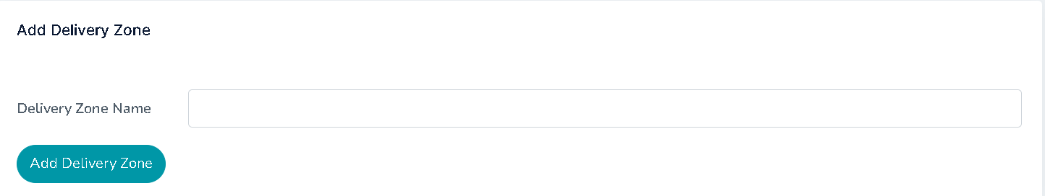

Step 2:
- View Delivery Zone
- Update Delivery Zone
- Delete Delivery Zone

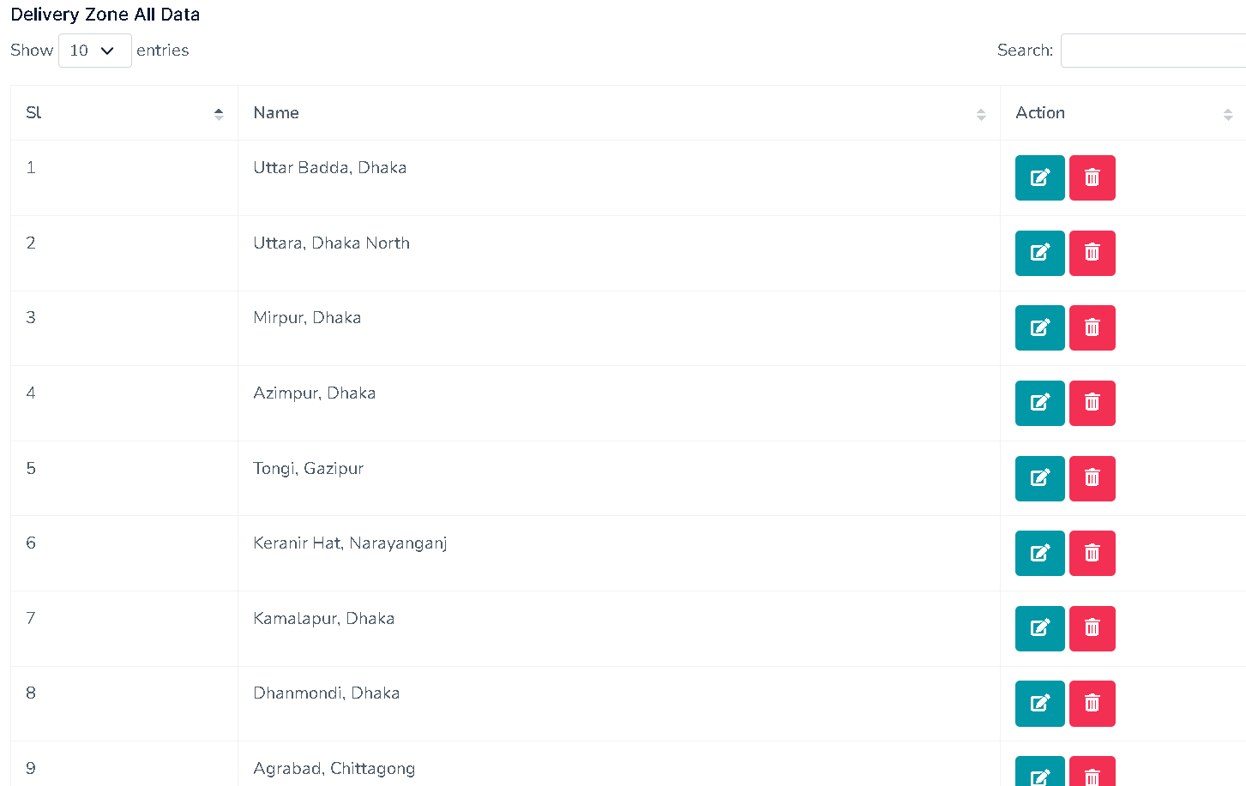
Figure 4.34: Delivery Zone Form.

4.6.7 Sales Representative (SR) Interface
Step 1: Add Sales Representative (SR)

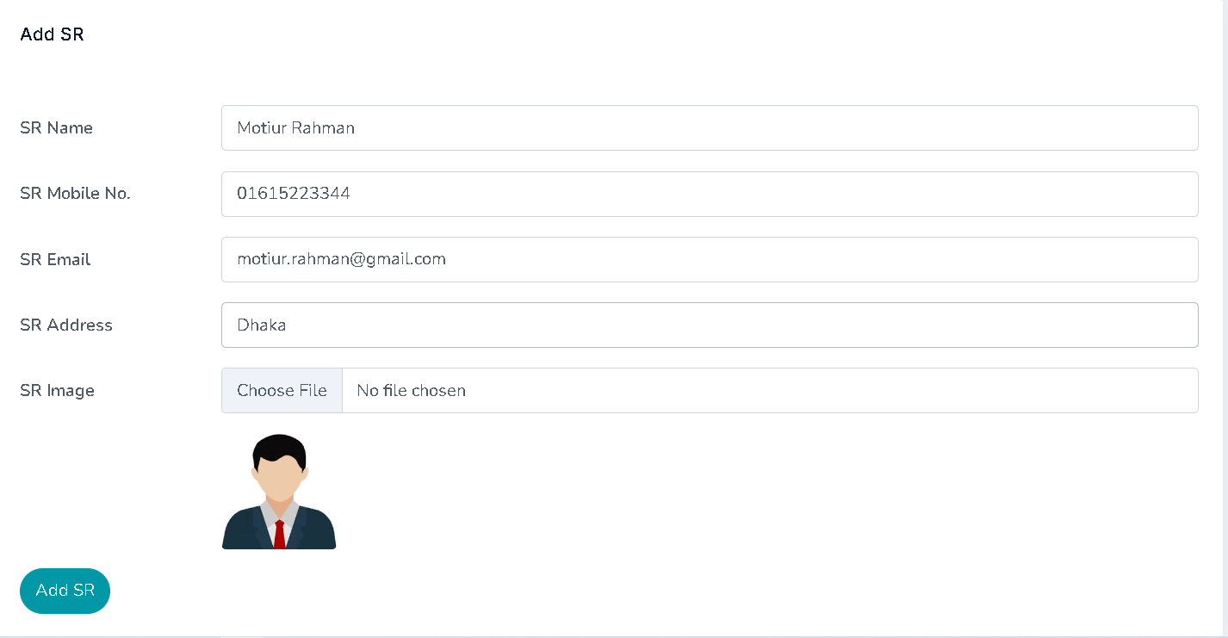
Step 2:
- View Sales Representative (SR)
- Update Sales Representative (SR)
- Delete Sales Representative (SR)
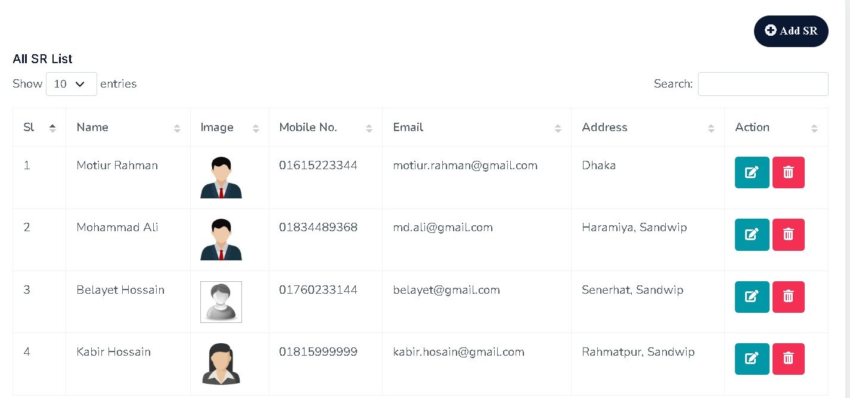
Figure 4.35: Sales Representative (SR) Form.

4.6.8 Purchase Receipt Interface
Step 1:
- Add Product from select button
- Click Add More
- Put Product Quantity
- Unit Price, DB Commission, Market Commission, Special Commission are automatic set from Product table as per previously store.
- Then Total Price of the individual product are auto calculative. There is no manual calculation
- Add More product as per need
- Delete product from red cross icon button if no need more.
- After that Sub Total for all the listed product are automatic sum out by noneditable mode.
- Here is the Total previous due shown automatically.
- Finally Save the data as Pending mode.
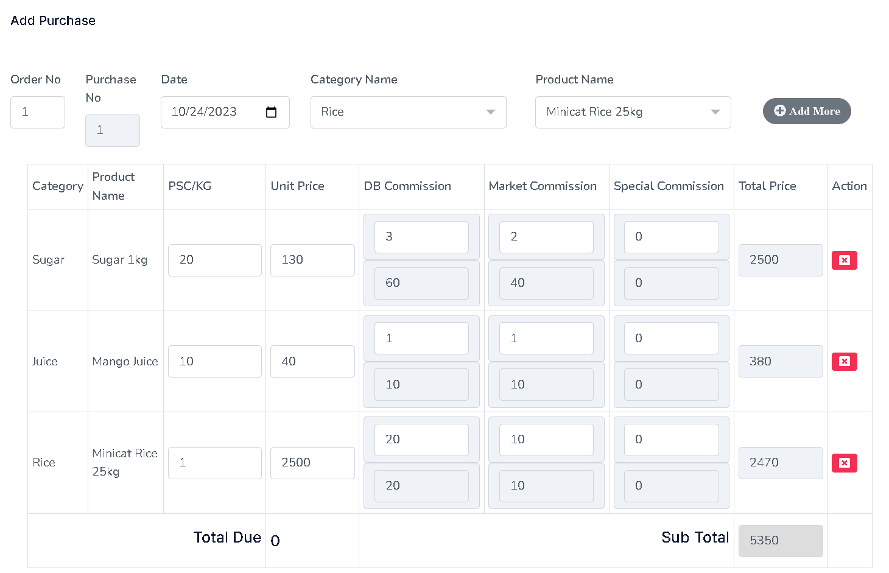
Figure 4.36: Add Purchase Form.
Step 2:
After purchase here is the purchase pending list whose are waiting for approval than it would be the final purchase products.
- Can edit purchase receipt
- Can delete
- Can only view print
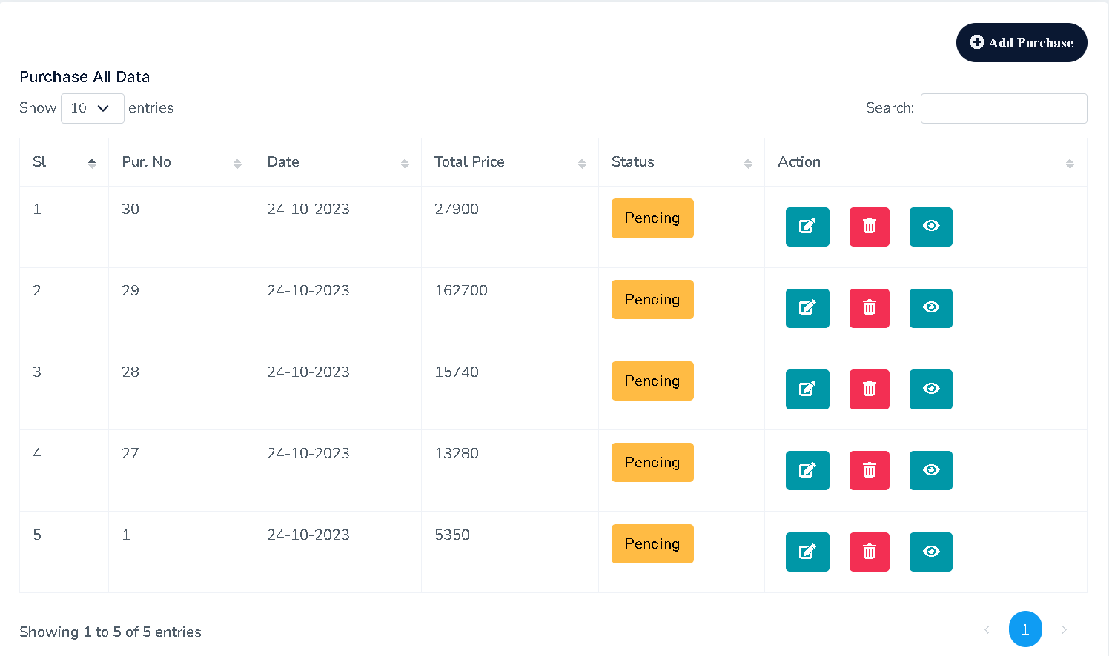
Figure 4.37: Purchase Dashboard Form.
Step 3:
- As previously created the purchase receipt it could be edited by add, remove, or update any data and can add new product.
- Update Save
- Make Approve the Purchase receipt
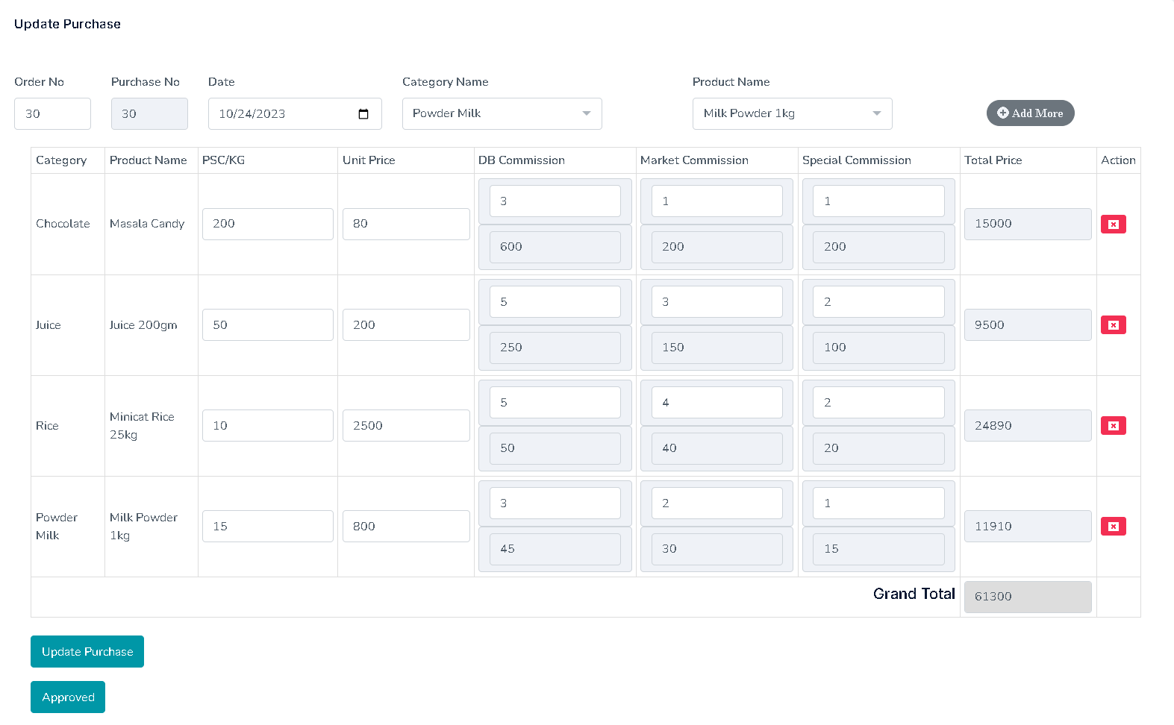
Figure 4.38: Purchase Receipt Update Form.

Step 4:
- View Updated Purchase Receipt List
- Status: Approved – No chance to update or edit approve receipt. A user can only view it and print it.
- Status: Pending – Waiting for approval. Pending Receipt can be delete or edit.
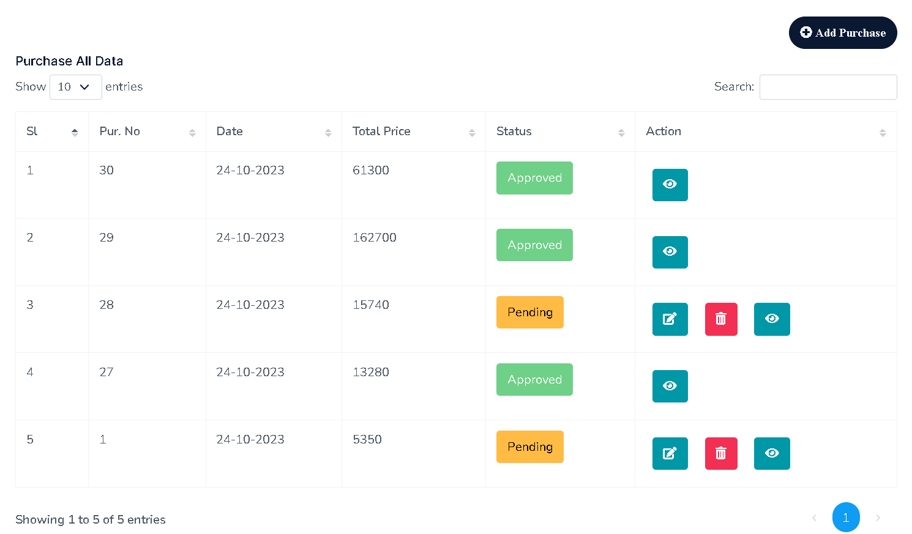
Figure 4.39: Updated Purchases List.

4.6.9 Purchase Payment

Step 1:
- Select Bank
- Payment Date
- Amount

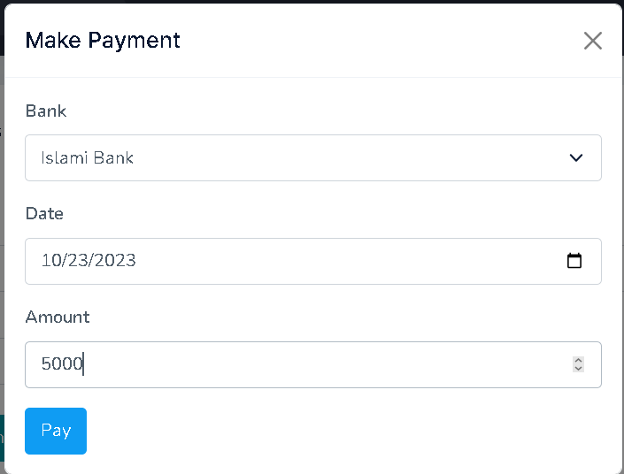
Figure 4.40: Make Purchase Payment.
Step 2:
- Status wise payment list.
- Approve: After approval then it would be effected as payment amount.
- Void: If payment transaction has been cancel or failed.
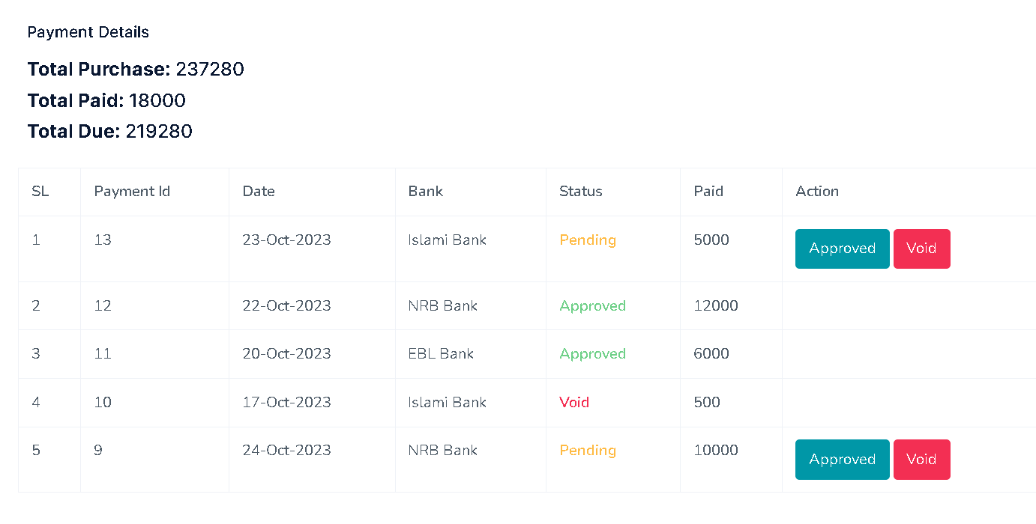
Figure 4.41: Purchase Payment list.

4.7 Sales Invoice

Steps Description:
- Add product from select button
- Click add more
- Put product quantity
- Sell commission is automatic set from product table as per previously store.
- Then total price of the individual product are auto calculative. There is no manual calculation
- Add more product as per needed.
- Delete product from red cross icon button if no need more.
- After that sub total for all the listed product are automatic sum out by noneditable mode.
- Here is the total previous due shown automatically.
- Enter discount amount.
- Select Payment mode
  - Full Paid: That’s mean no due at all.
  - Full Due: No amount to be paid for this invoice.
  - Partial Paid: Some of total amount to be paid remaining amount is due.
- Select delivery zone
- Select Sales Representative (SR): Who will bring these product to deliver.
- Finally save the complete data as pending mode.
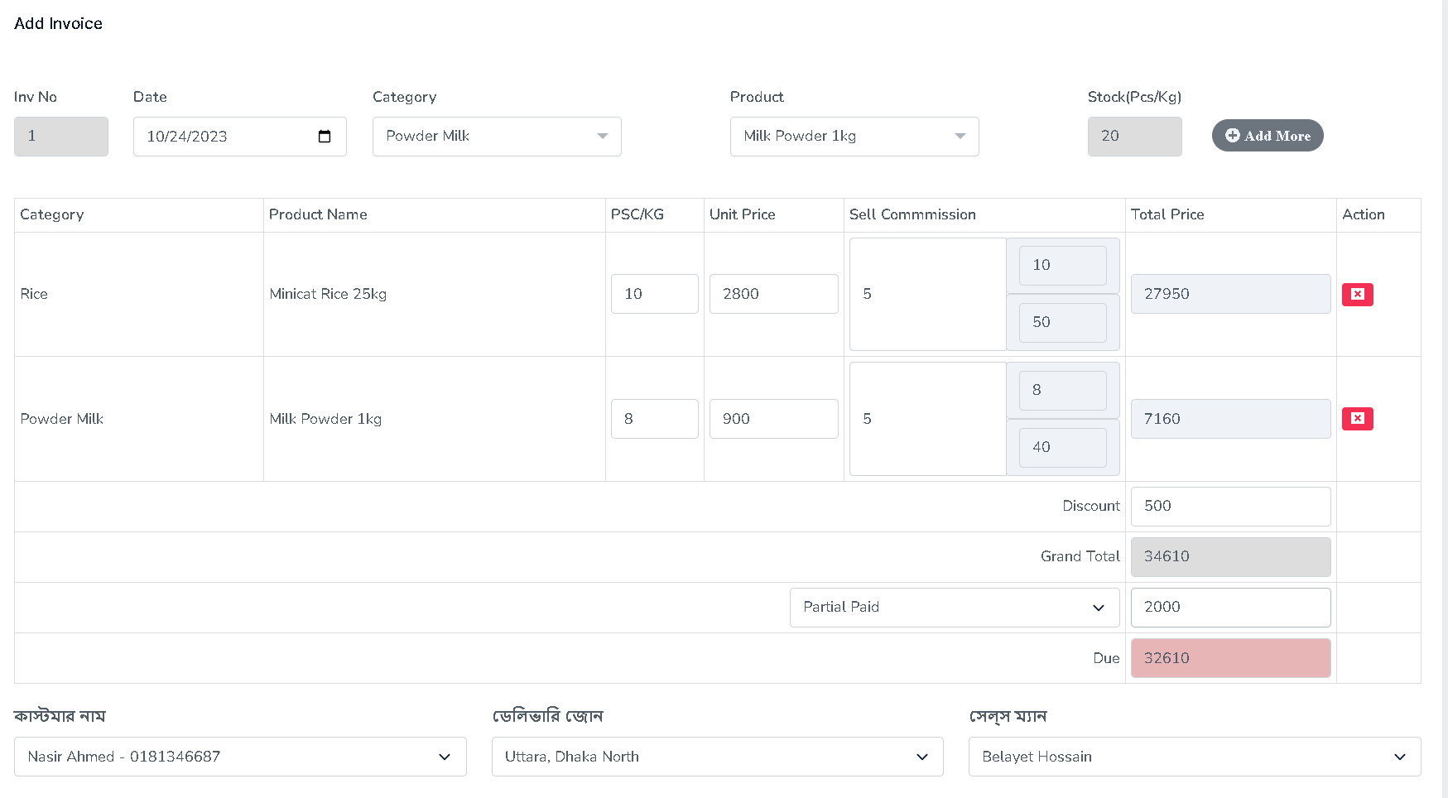
Figure 4.42: Sales Invoice Form.

4.7.1 Sales Invoice Dashboard

Status wise update invoice lists are showing here.
- Approved: Only view and Print
- Pending: Can Edit, Update, Delete the total invoice by clicking the delete button.

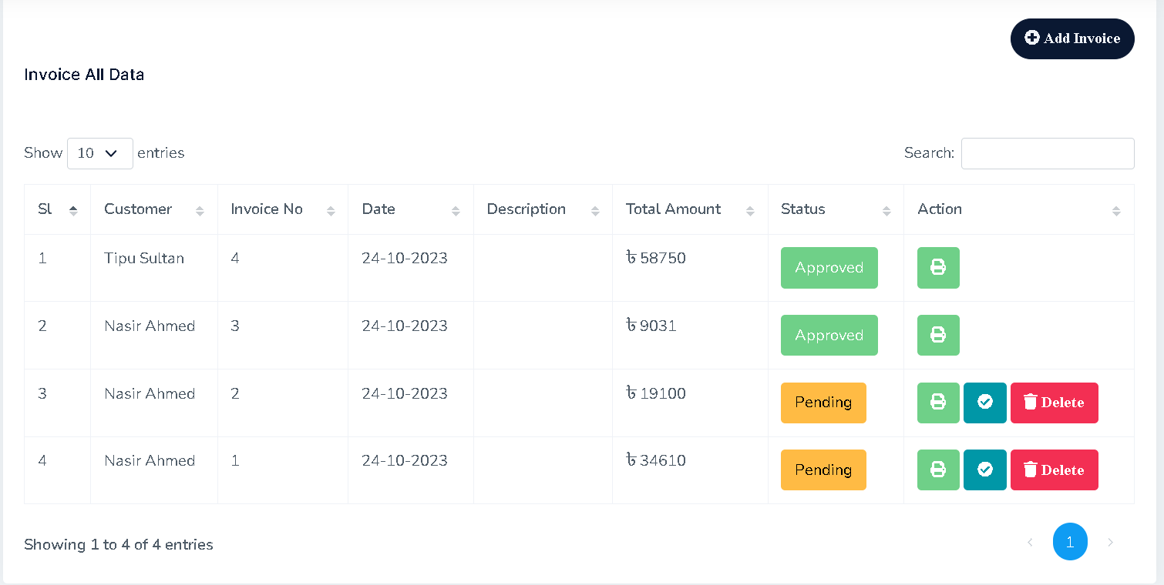
Figure 4.43: Sales Invoice Dashboard.

4.7.2 Update Sales Invoice Receipt

From Edit button here is the option to update the pending sales invoice receipt.
- Edit Invoice
- Insert new product as per needed.
- Delete product if needed.
- Finally approve the invoice
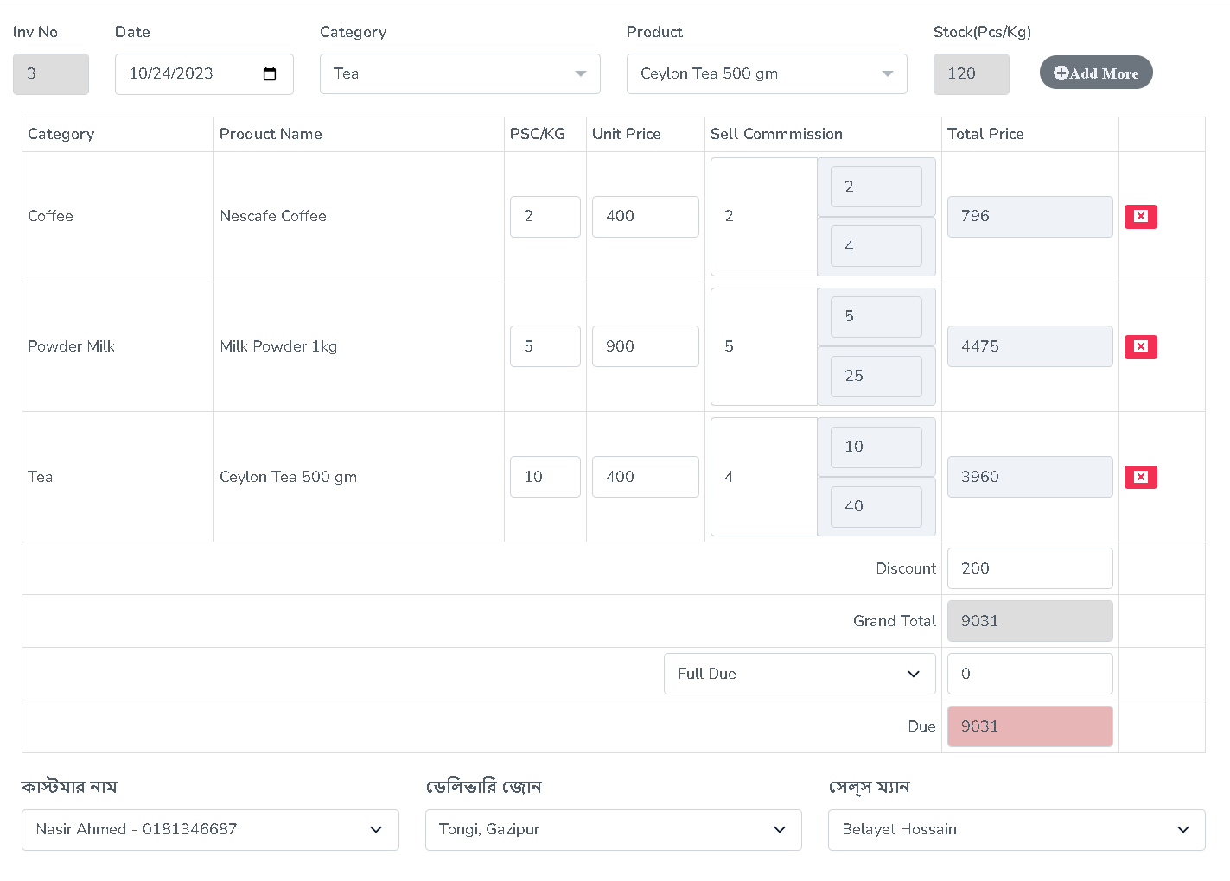
Figure 4.44: Update Sales Invoice Form.
4.7.3 Print Sales Invoice Receipt
- Sales person can print the invoice receipt
- Can Save as PDF for further use

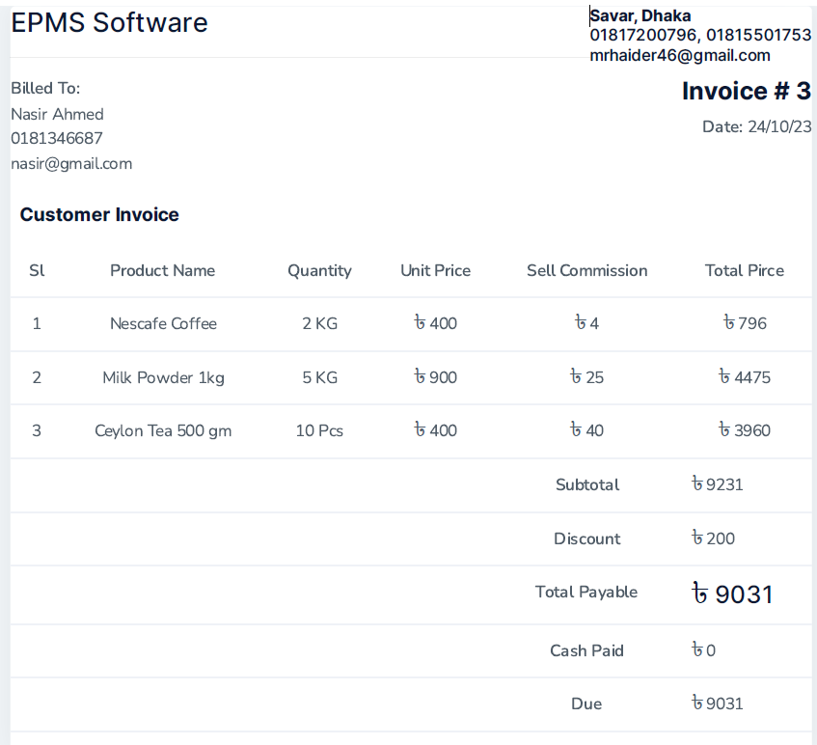
Figure 4.45: Sales Invoice Receipt Print.

4.8 Testing Reports

- Purchase Report
- Purchase Payment Report
- Sales Invoice Report
- Customer invoice
- Product list
- Customer Report
- Customer Due/Paid Report
- Product Stock report

4.8.1 Purchase Report

All kind of purchase report generating here by searching some criteria.
- Purchase No
- Status wise (Approved, Pending)
- Date wise (Ex. Start Date to End Date)

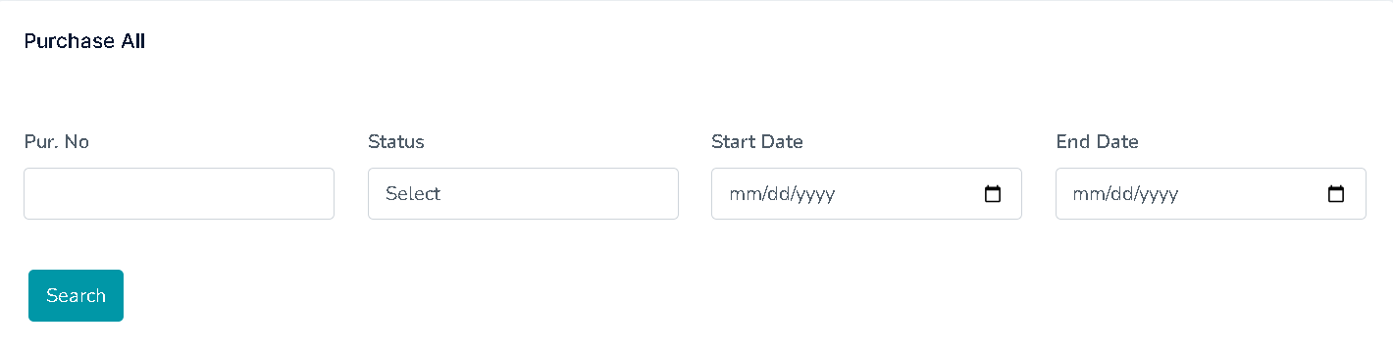
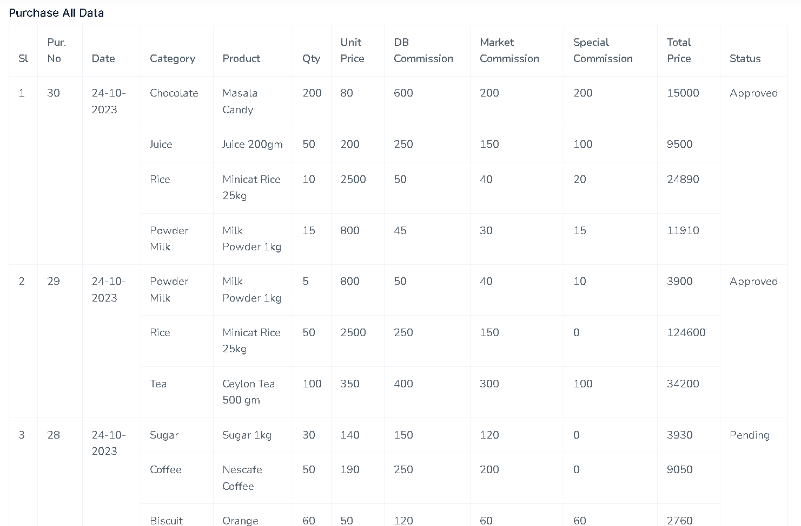

Figure 4.46: Purchase Report.

4.8.2 Purchase Payment Report

Can finding payment report by searching some criteria.
- Payment No
- Status wise (Approve, Pending, Void)
- Bank wise (Ex. Islami Bank, EBL, Sonali Bank)
- Date wise (Ex. Start Date to End Date)

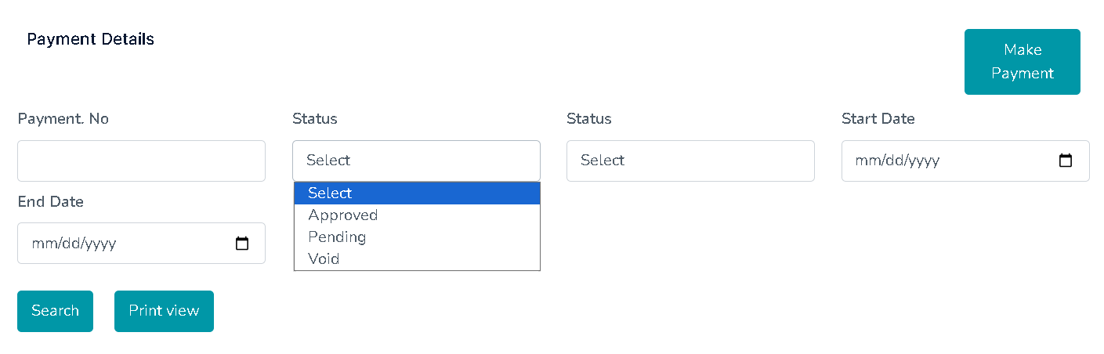

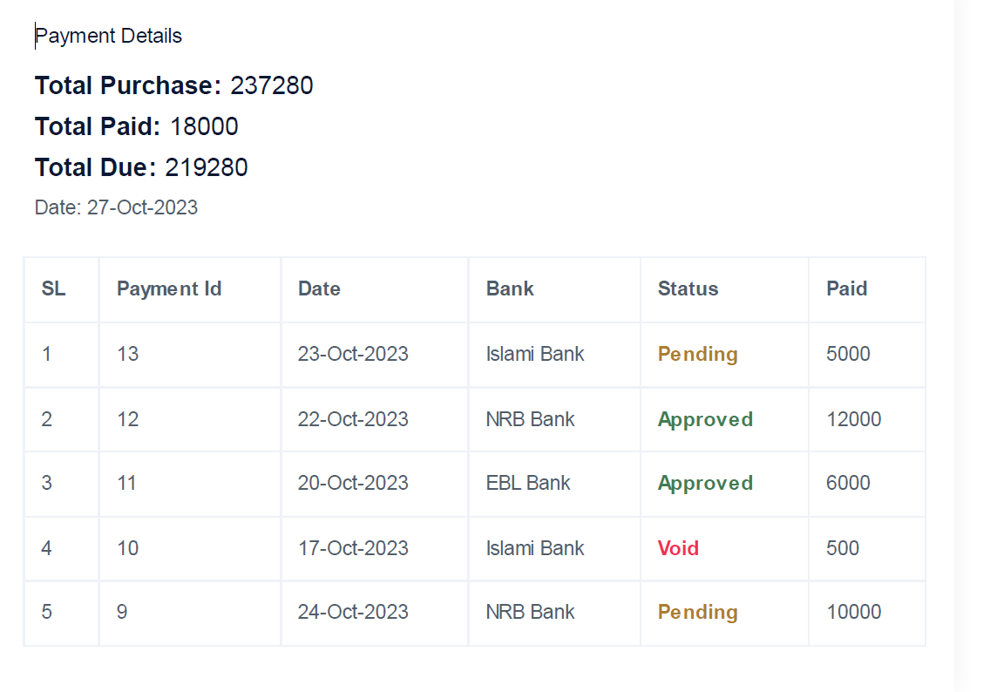
Figure 4.47: Purchase Payment Report.

4.8.3 Sales Invoice Report

Showing report date wise
- Customer Name
- Invoice Date
- Total amount
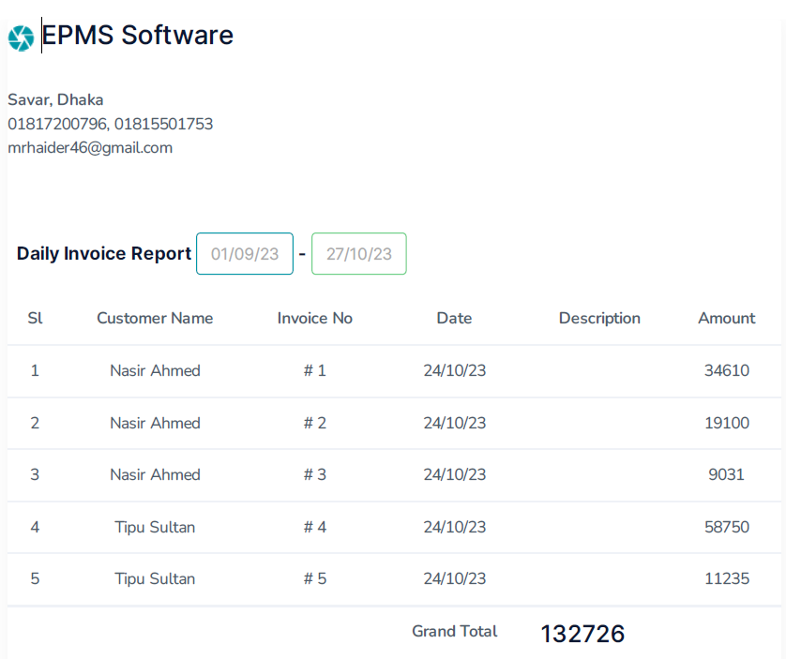
Figure 4.48: Sales Invoice Report.

4.8.4 Customer wise Invoice Report
Report body
- Customer name
- Customer address
- Phone number
- Email
- Invoice no
- Product lists
- Sell commission
- Discount
- Paid amount
- Total due

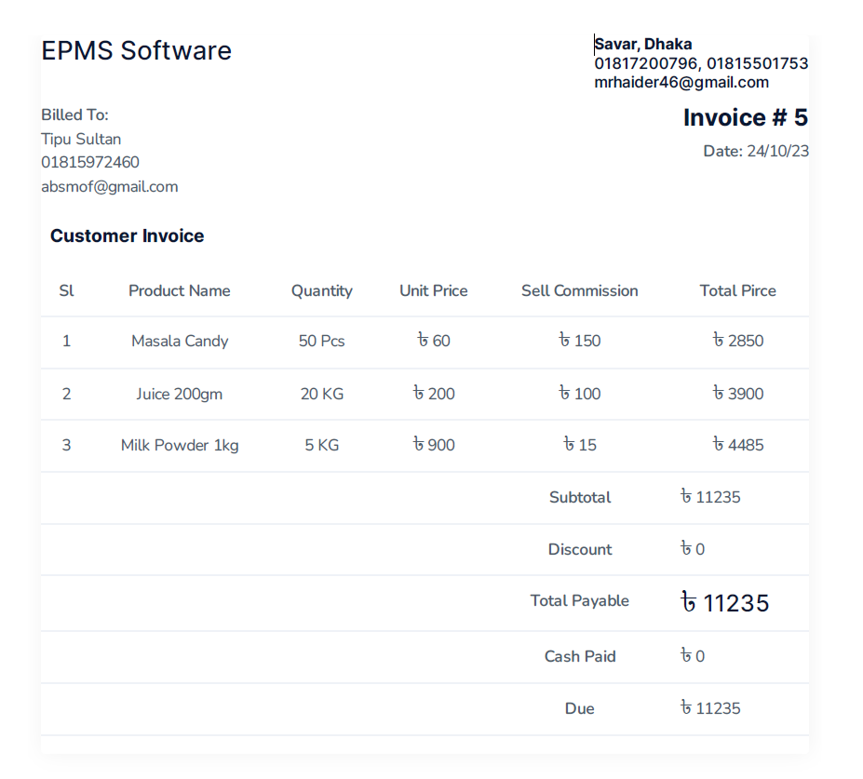
Figure 4.49: Customer Invoice Report.

4.8.5 Customer Due Report
Report body
- Customer name
- Invoice No
- Date
- Total due

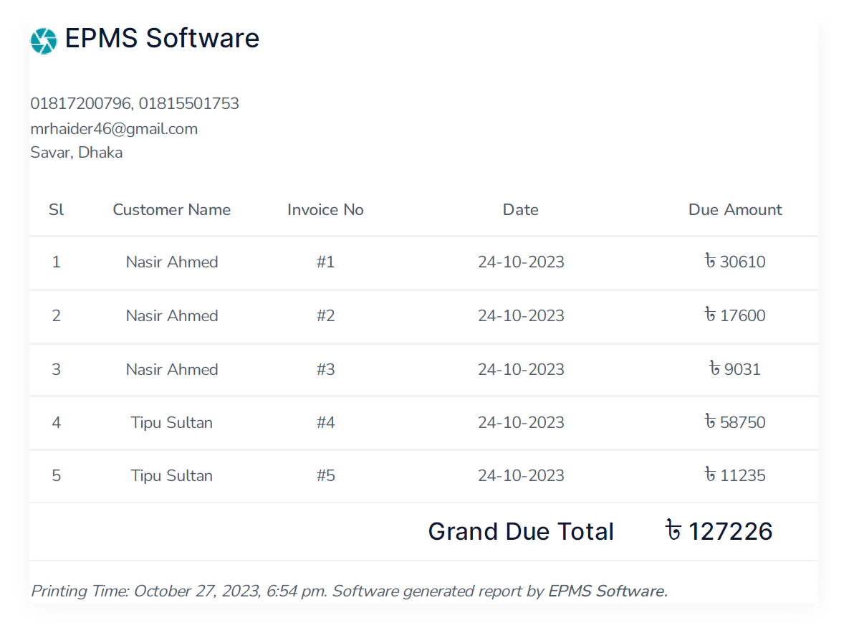
Figure 4.50: Customer Due Report.

4.8.6 Product List Report
Report body
- ProductName
- Product Image
- Supplier
- Category
- Units
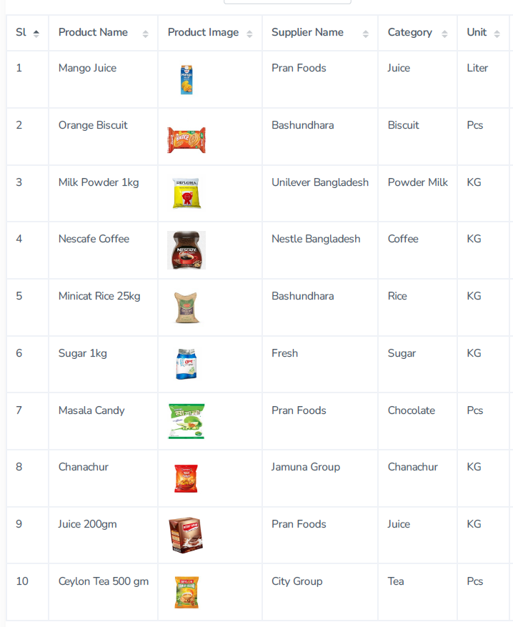
Figure 4.51: Product Lists Report.

4.8.7 Product Stock Report

Product stock is showing how many of products are available in the current stock.

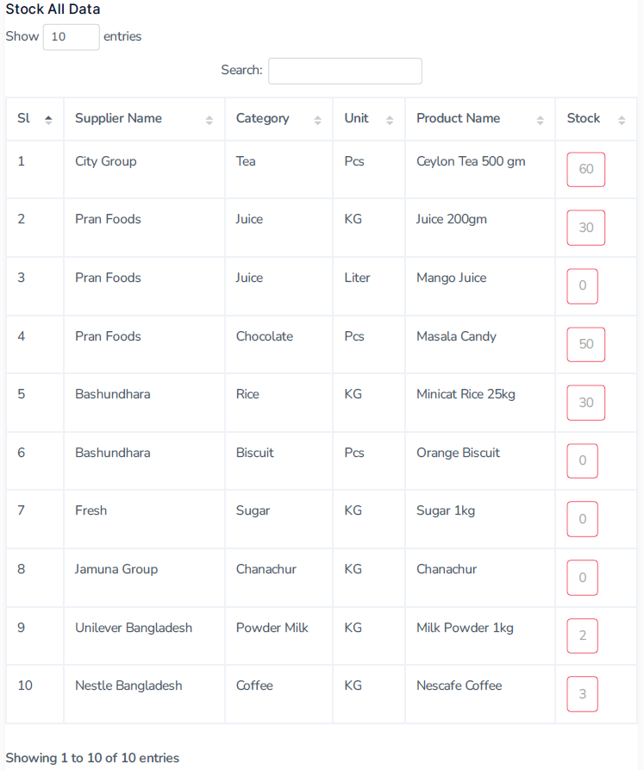
Figure 4.52: Product Stock Report.

Chapter 5

Conclusion and Future Work

5.1 Conclusion
Enterprise Product Management System (EPMS) will be very useful and needful software for a medium level of business, especially a wholesales business or retailer business. Because in EPMS there are built-in available facilities to deliver their products by dynamically creating a Sales Representative (SR) and Delivery Zone. There is no need to calculate manually for any kind of purchase, sales, or product stock. This software facilitates all kinds of calculations for customer due amount and paid amount, as well as purchases paid to the merchant. All business data are kept very securely in the database forever. User access control is very much secured by dynamic and strong passwords through email verification. Accessing the software from anywhere anytime by 24/7 process. The software is totally device responsible for all kinds of devices like Mobile, Laptop, Tab or any size of Desktop computer. So that no worries about accessing the software with authenticated users. I think EPMS Software makes the business more profitable, more easier, and more accurate. The business improving and progressing day by day by using EPMS Software.

5.2 Contribution

Enterprise Product Management System (EPMS) hugely contributes to the business progress with modern trends. Quick and accurate calculations will effectively contribute to the business's profit. The hassle-free transaction with customer and merchant. Some examples are given following:
- 24/7 services if needed.
- Data are kept securely stored in the Database forever.
- Faster and quick accurate income and expenses calculations.
- Customer due and paid calculation will be automatically adjusted after payment or invoice.
- Available product stock will be notified after the low of stock.
- Proper form validation can prevent unnecessary transactions. Ex. Like if a product is not available then that product will not be added to the sale invoice.

5.3 Future Work

In the future, I will work for the Enterprise Product Management Software (EPMS) to more extent by adding some updated trends to make it a more automated system. The plans are following to update the new version of EPMS.

- Mobile Apps Integration: Android apps will be created by integrated with this EPMS.
- Bar-code Scan: For sales invoices and purchase receipts, the Bar-code will make it faster and smoother products add [2, 3].
- SMS: After sales, a customer can receive a digital receipt through SMS. Also, a customer will be notified by SMS about their total previous due.
- Email Integration: By Email, a customer can receive an invoice receipt.
- Payment Gateway: A digital payment gateway will be available for receipt of digital payment through eBanking payment, VISA/Master Card Payment, and Mobile banking like bKash, Rocket, and Nagad payment [1].
- User-wise Access: Add more restrictions and rule by user-wise access control.

References

[1] | Shalom Adonai Huaraz Morales and Laberiano Andrade-Arenas, "Inventory Management Analysis under the System Dynamics Model," (IJACSA) International Journal of Advanced Computer Science and Applications,  Vol. 12, No. 1, 2021
[2] | Thomas Muyumba and Jackson Phiri, "A Web based Inventory Control System using Cloud Architecture and Barcode Technology for Zambia Air Force," (IJACSA) International Journal of Advanced Computer Science and Applications, Vol. 8, No. 11, 2017
[3] | Hayder Sabah Salih, Mohanad Ghazi, Mohammad Aljanabi "Implementing an Automated Inventory Management System for Small and Medium-sized Enterprises", Journal IJCSM 'Iraqi Journal for Computer Science and Mathematics', (May, 2023), http://journal.esj.edu.iq/index.php/IJCM
[4] | Chan Chin, Sathiapriya Ramiah and Nurul Farhaini Razali "Inventory Management Systems (IMS)" Journal of Applied Technology and Innovation (e -ISSN: 2600-7304) vol. 7, no. 3, (2023), https://www.researchgate.net/publication/372653862_Inventory_Management_Systems_IMS
[5] | M.Mukherjee, "Object-Oriented Analysis and Design," International Journal of Advanced Engineering and Management”, Vol. 1, No. 1, pp. 18-24, 2016.
[6] | Novia Fuji Lestari and Yuanita Handayati "Analysis of Inventory Management in Order to Reduce Overstock", International Journal of Current Science Research and Review, Volume 05 Issue 09 September 2022
[7] | Sutini and Wisnu Yuwono "Implementing Inventory Management System  At Toko Sinar Pratama", Conference on Community Engagement Project, Vol. 2, No. 1, (2022), https://journal.uib.ac.id/index.php/concept
[8] | M.Mukherjee "Object-Oriented Analysis and Design", International Journal of Advanced Engineering and Management, Vol. 1, No.1, PP. 1-11, 2016
[9] | Tinuke O. Oladele, Roseline Oluwaseun Ogundokun, Adekanmi Adeyinka Adegun, Emmanuel Abidemi Adeniyi, Ayobami Tayo Ajanaku, "Development of an inventory management system using association rule", Indonesian Journal of Electrical Engineering and Computer Science, Vol. 21, No. 3, March 2021
[10] | Agboola, Malgwi, Mahmud, And Oguntoye, "Development Of A Web-Based Platform For Automating An Inventory Management Of A Small And Medium Enterprise", Fudma Journal Of Sciences (Fjs), Vol. 6 No. 5, October, 2022
[11] | Nwafor Chidinma Anulika, Idoko Nnmadi A, Agbo Jonathan Chukwuwike, Ogbene Nnaemeka Emeka, "Design and Optimization of An Inventory Management System for Central Stores", International Journal of Interdisciplinary Innovative Research &Development (IJIIRD) ISSN: 2456-236X Vol. 05 Issue 01 | 2020
[12] | Qiuying Han, "Inventory System Based on ThinkPHP and Bootstrap Framework", American Journal of Theoretical and Applied Research (AJTP), AJTAR, 2019
[13] | Laravel Official Website, https://laravel.com
[14] | Bootstrap Official Website, url: https://getbootstrap.com
[15] | Tutorial Point, https://www.tutorialspoint.com/laravel/laravel_overview.htm
[16] | jQuery Official Website, https://jquery.com/
[17] | Commerce Mates Study, https://commercemates.com
[18] | Share your Study, https://www.shareyouressays.com/knowledge/7-main-scopes-of-product-control-and-management/116410
[19] | Bondedservice,http://www.bondedservice.com/what-is-web-based-inventory-management
[20] | Php Official, https://www.php.net
[21] | Wikipedia Php, https://en.wikipedia.org/wiki/PHP
[22] | Java Tutorial Point, https://www.javatpoint.com
[23] | W3School Bootstrap, https://www.w3schools.com/bootstrap

